Circular–Organic Open Shapes
# Source: AI Source: Provided by: [Data Path: Persons Table -> ID Column: 1, Name_En Column: Motasem Essam] -> From: [ChatGPT] on [7/25/2026]
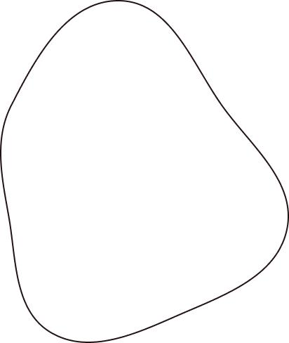
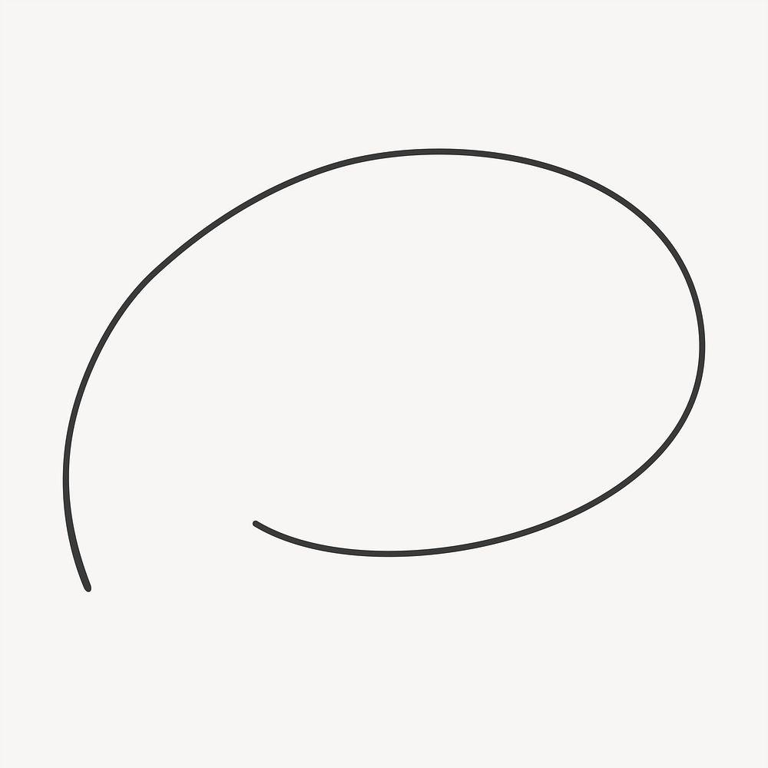
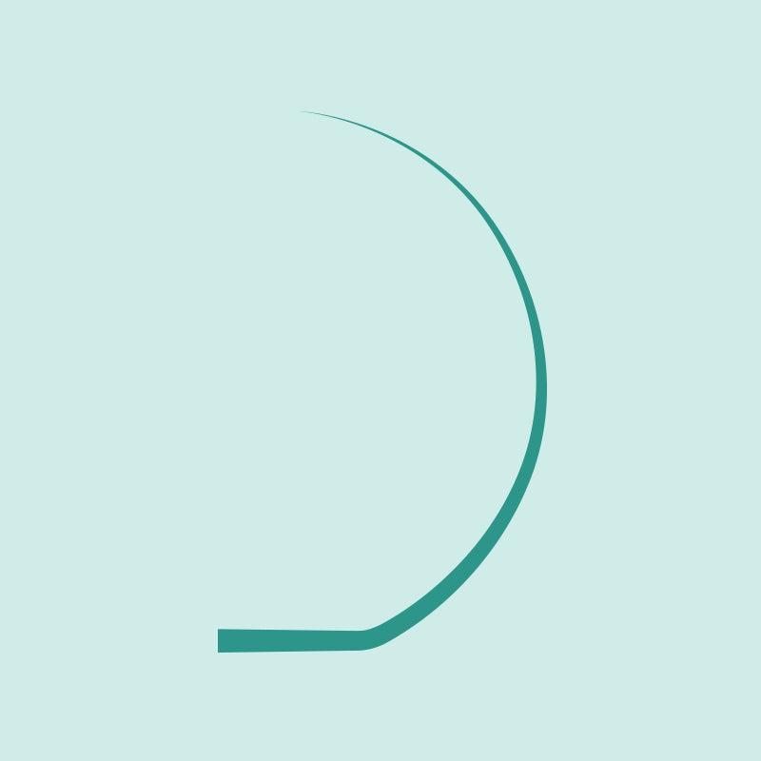


Definition
# Source: AI Source: Provided by: [Data Path: Persons Table -> ID Column: 1, Name_En Column: Motasem Essam] -> From: [ChatGPT] on [7/25/2026]
A Circular–Organic Open Shape is an open mixed shape that combines one or more circular arcs with irregular, natural-looking organic curved portions.
$$\boxed{\text{Circular–Organic Open Shape}=\text{Circular Arc(s)}+\text{Organic Curve(s)}+\text{Open Boundary}}$$
The shape is open because its path does not completely connect to form a closed boundary.

Characteristics
# Source: AI Source: Provided by: [Data Path: Persons Table -> ID Column: 1, Name_En Column: Motasem Essam] -> From: [ChatGPT] on [7/25/2026]
A Circular–Organic Open Shape:
- Is open.
- Contains at least one circular arc.
- Contains at least one organic curved portion.
- Combines regular circular geometry with irregular natural-looking curvature.
- Has two or more endpoints.
- May have smooth transitions between curves.
- May have changes in curvature.
- Can be symmetric or asymmetric.
- Can be simple or complex.
- Does not enclose an area by itself.

Types of Circular–Organic Open Shapes

1. Simple Circular–Organic Open Shape
# Source: AI Source: Provided by: [Data Path: Persons Table -> ID Column: 1, Name_En Column: Motasem Essam] -> From: [ChatGPT] on [7/25/2026]
A simple open path combining a circular arc with one organic curved section.
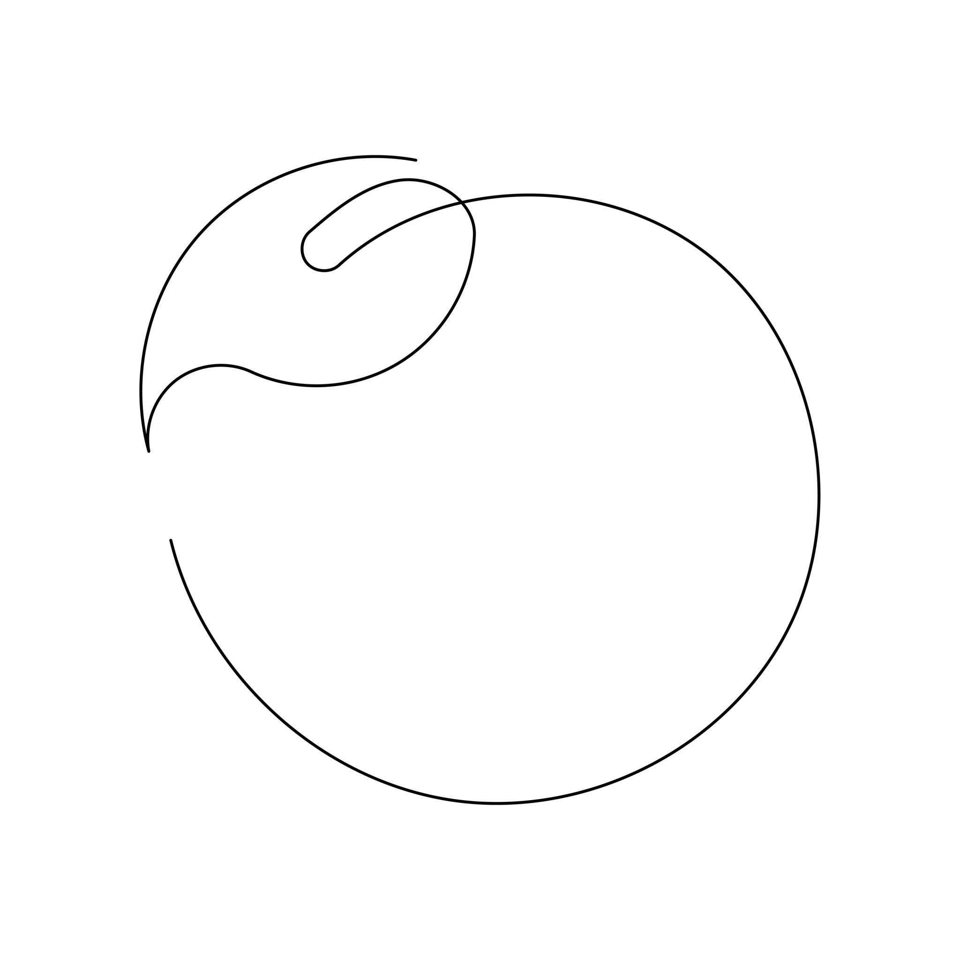
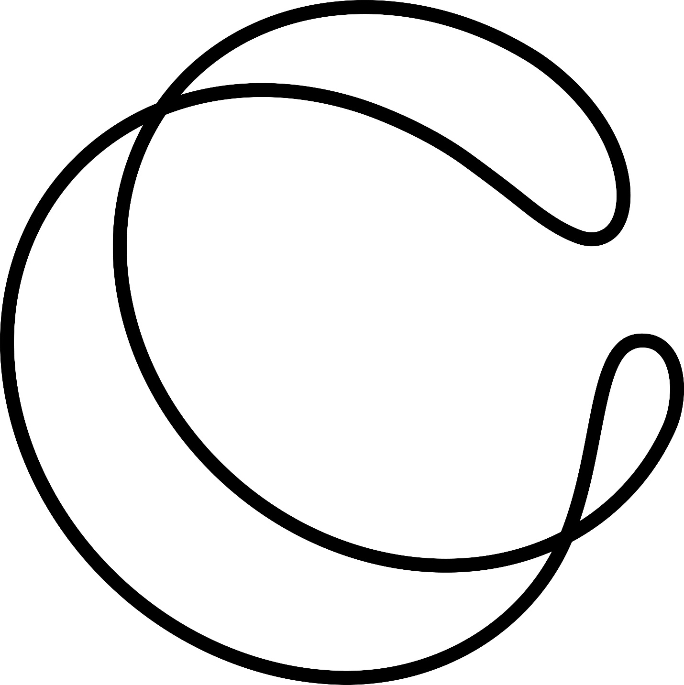
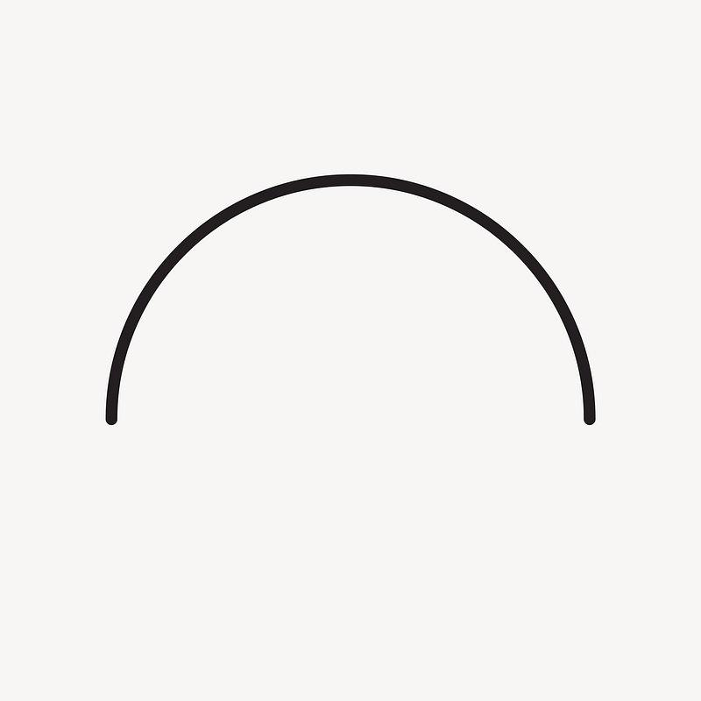
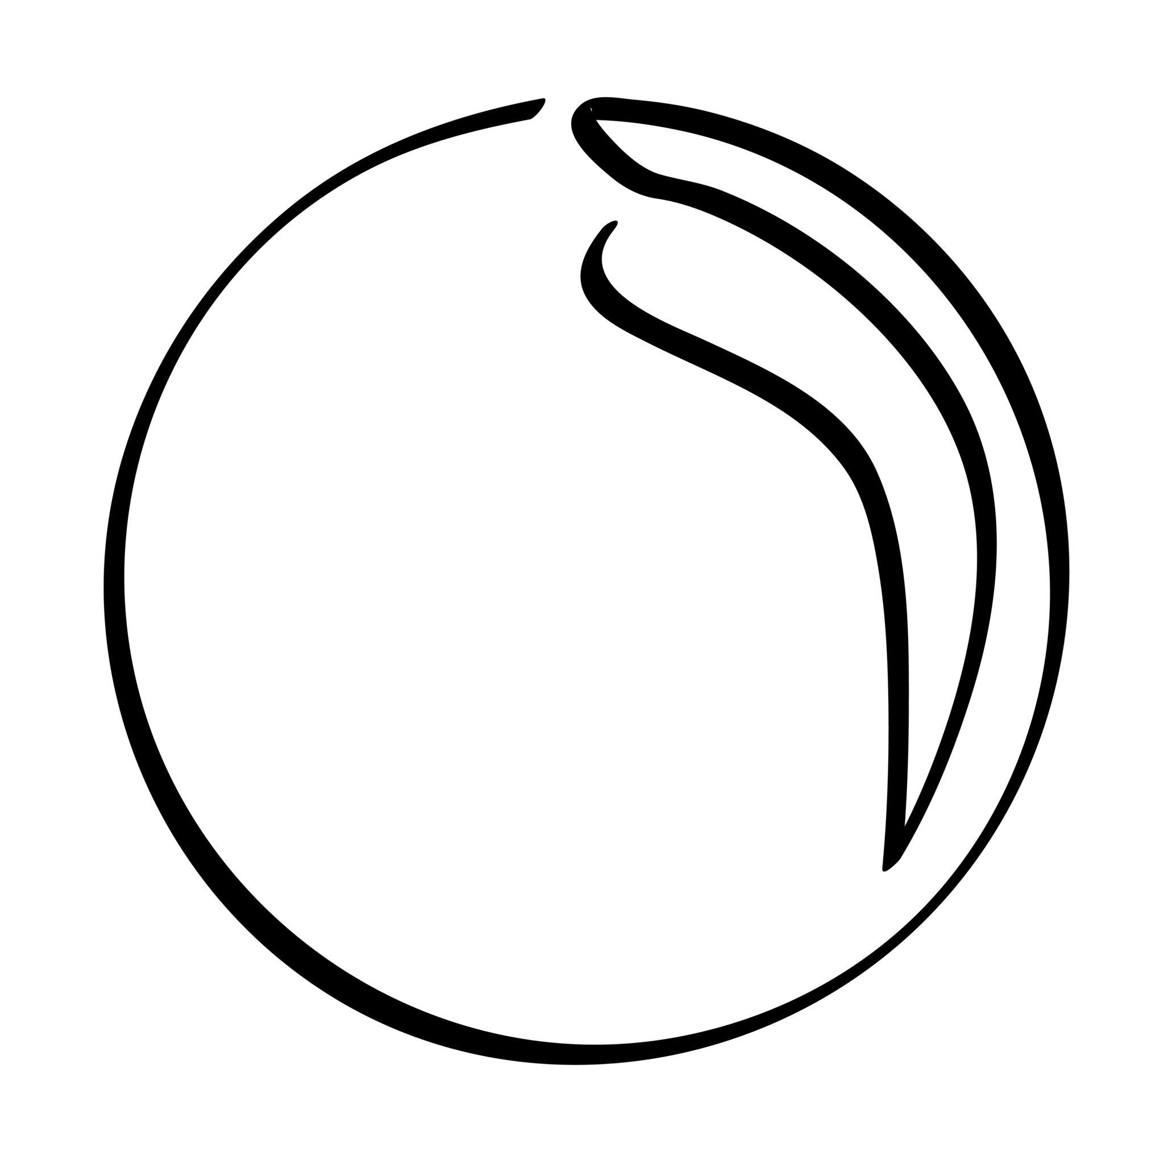

2. Irregular Circular–Organic Open Shape
# Source: AI Source: Provided by: [Data Path: Persons Table -> ID Column: 1, Name_En Column: Motasem Essam] -> From: [ChatGPT] on [7/25/2026]
A combination of circular and organic curves with irregular lengths, positions, or curvature.
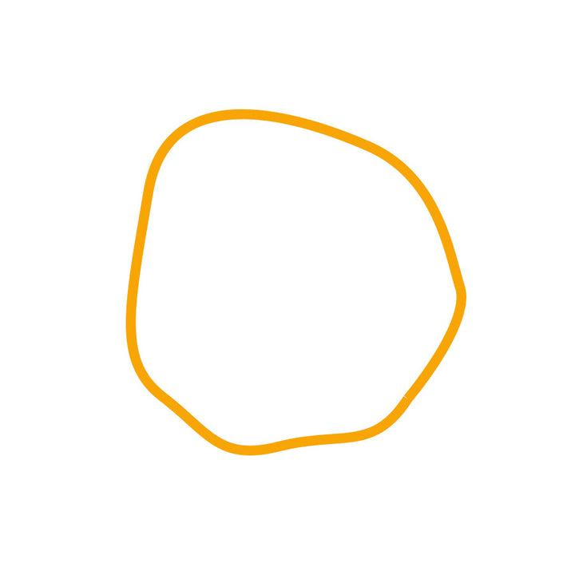
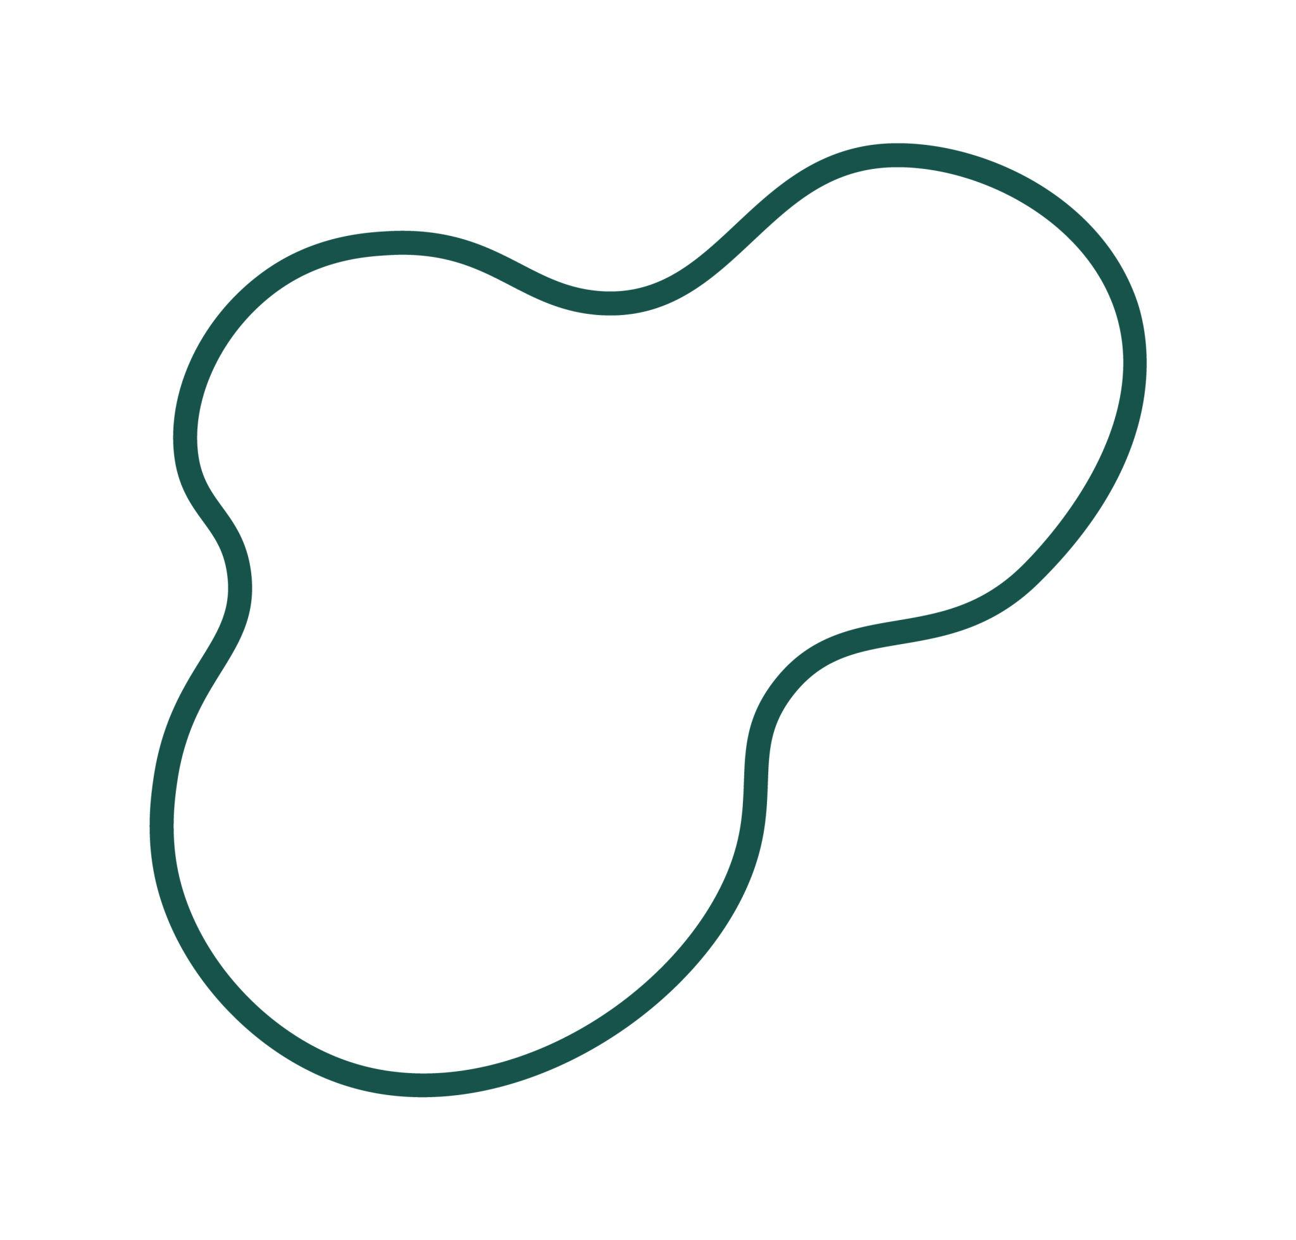
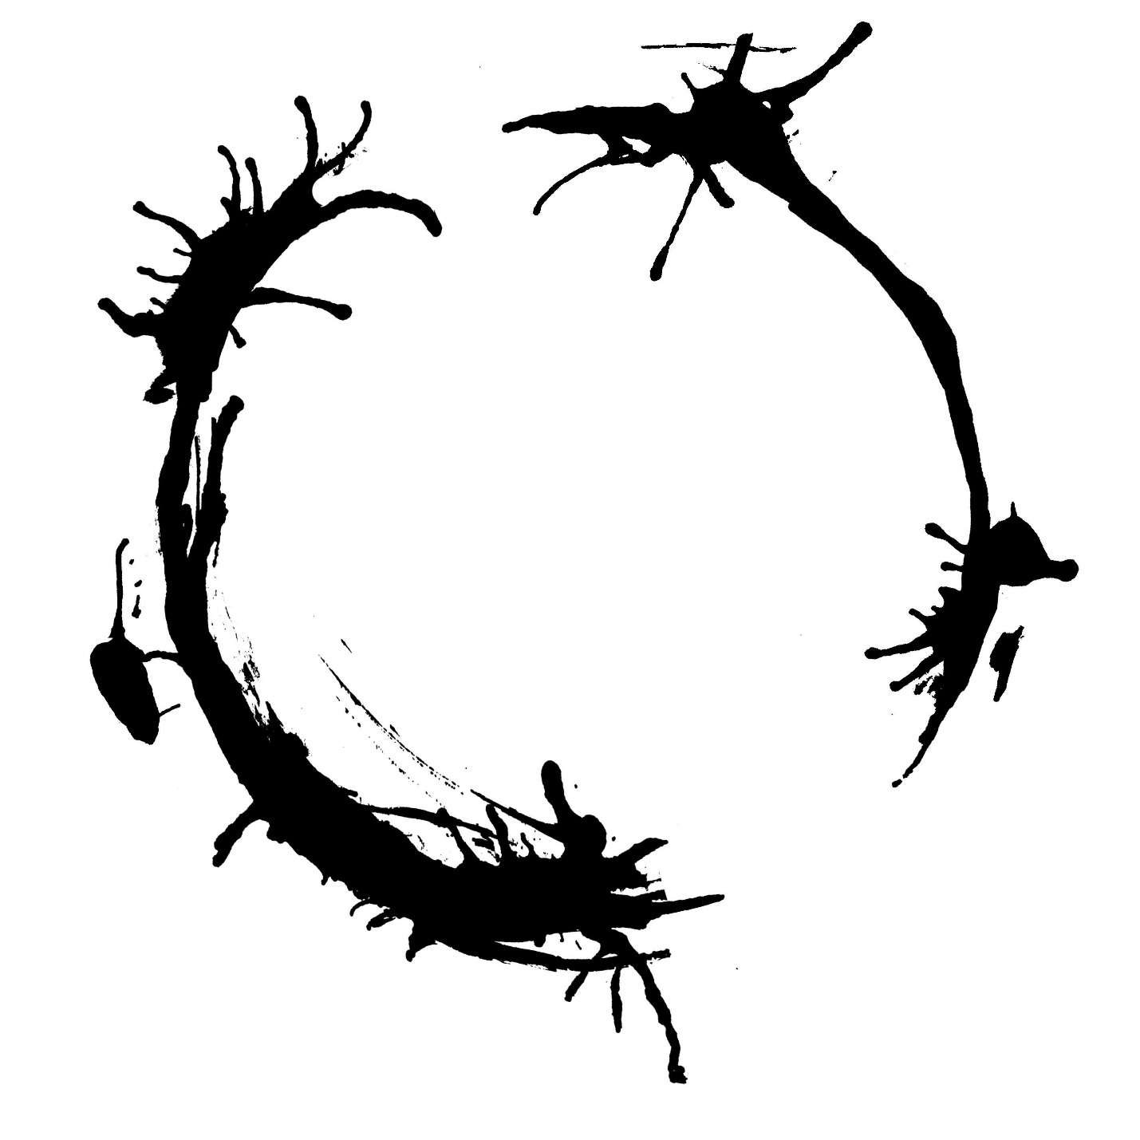

3. Natural Circular–Organic Open Shape
# Source: AI Source: Provided by: [Data Path: Persons Table -> ID Column: 1, Name_En Column: Motasem Essam] -> From: [ChatGPT] on [7/25/2026]
A natural-looking open form containing a recognizable circular portion together with an organic curved portion.
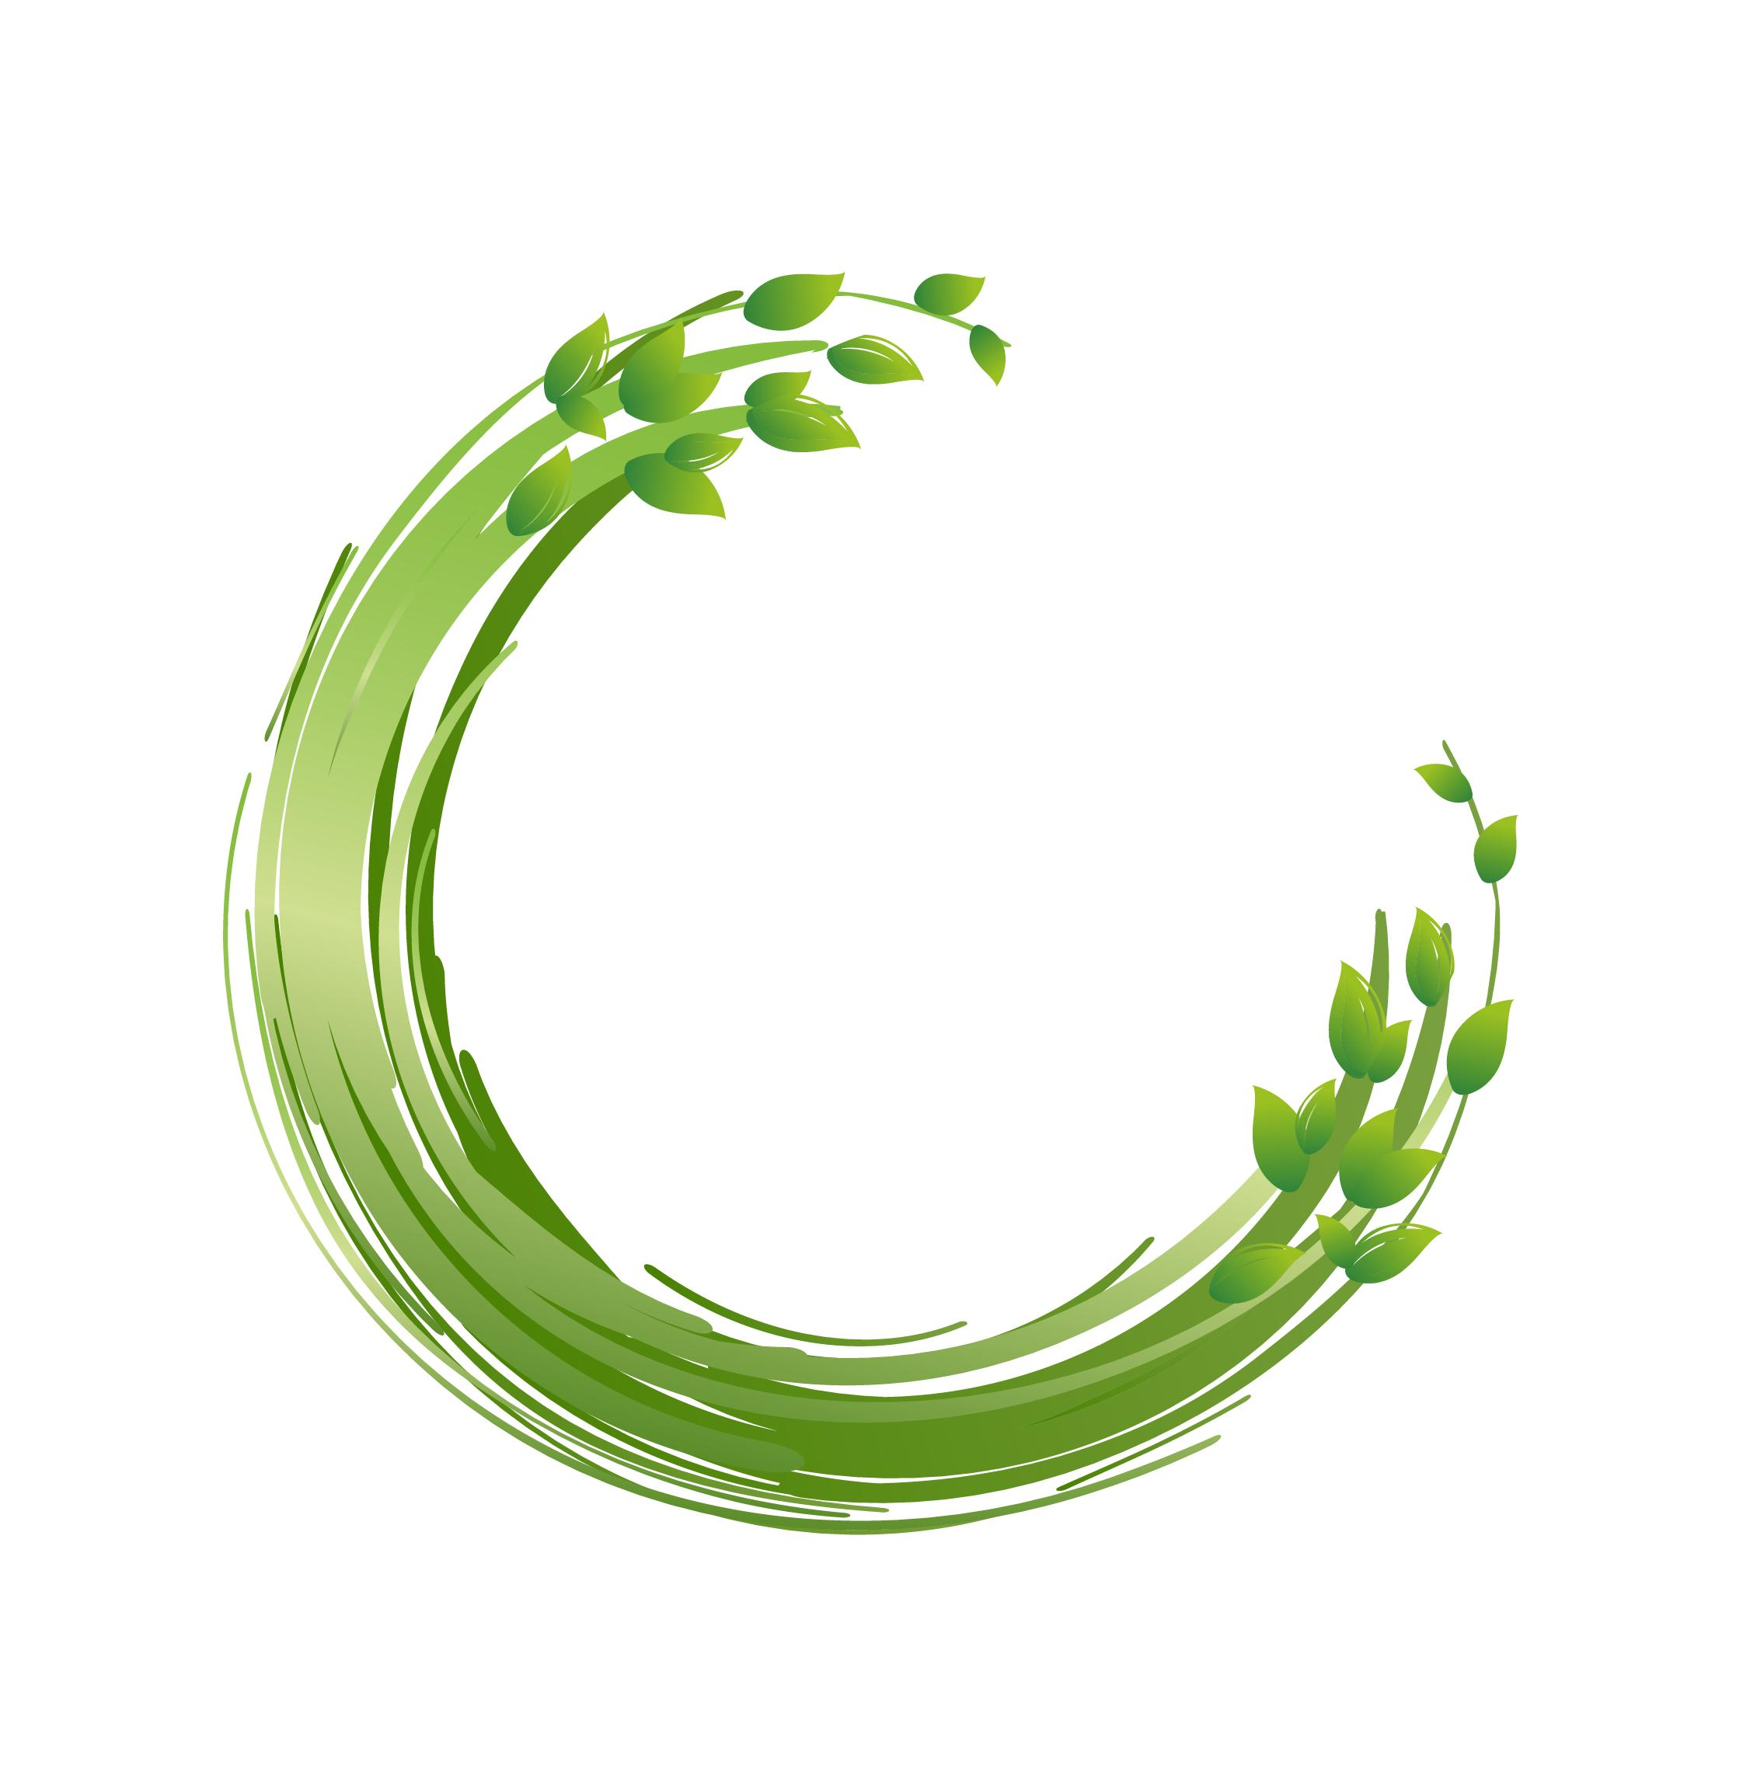

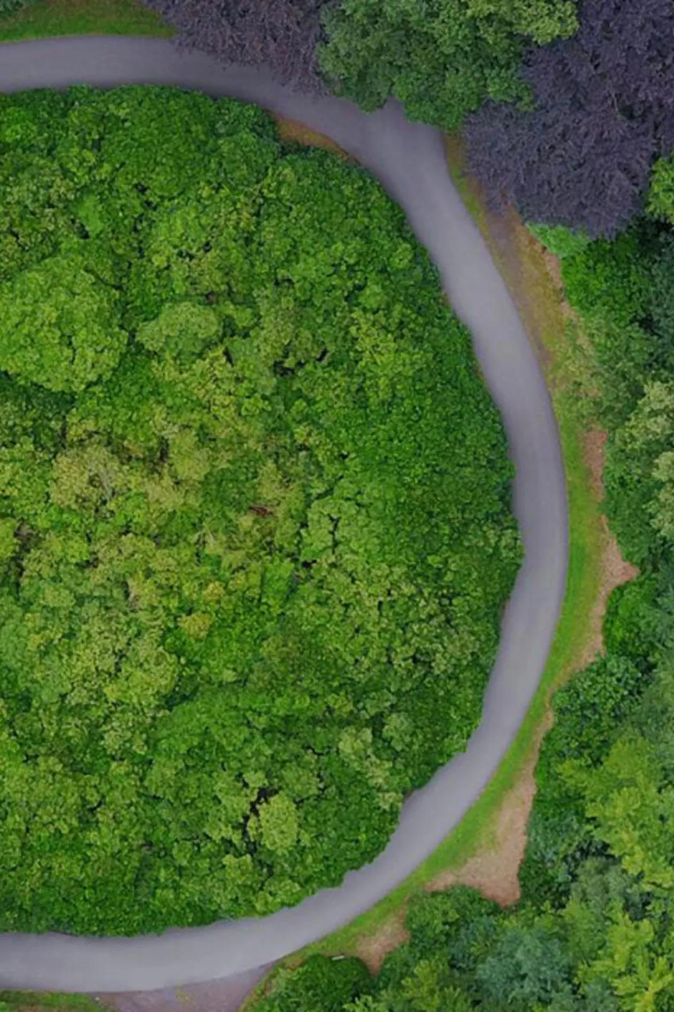
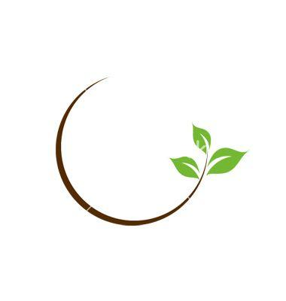
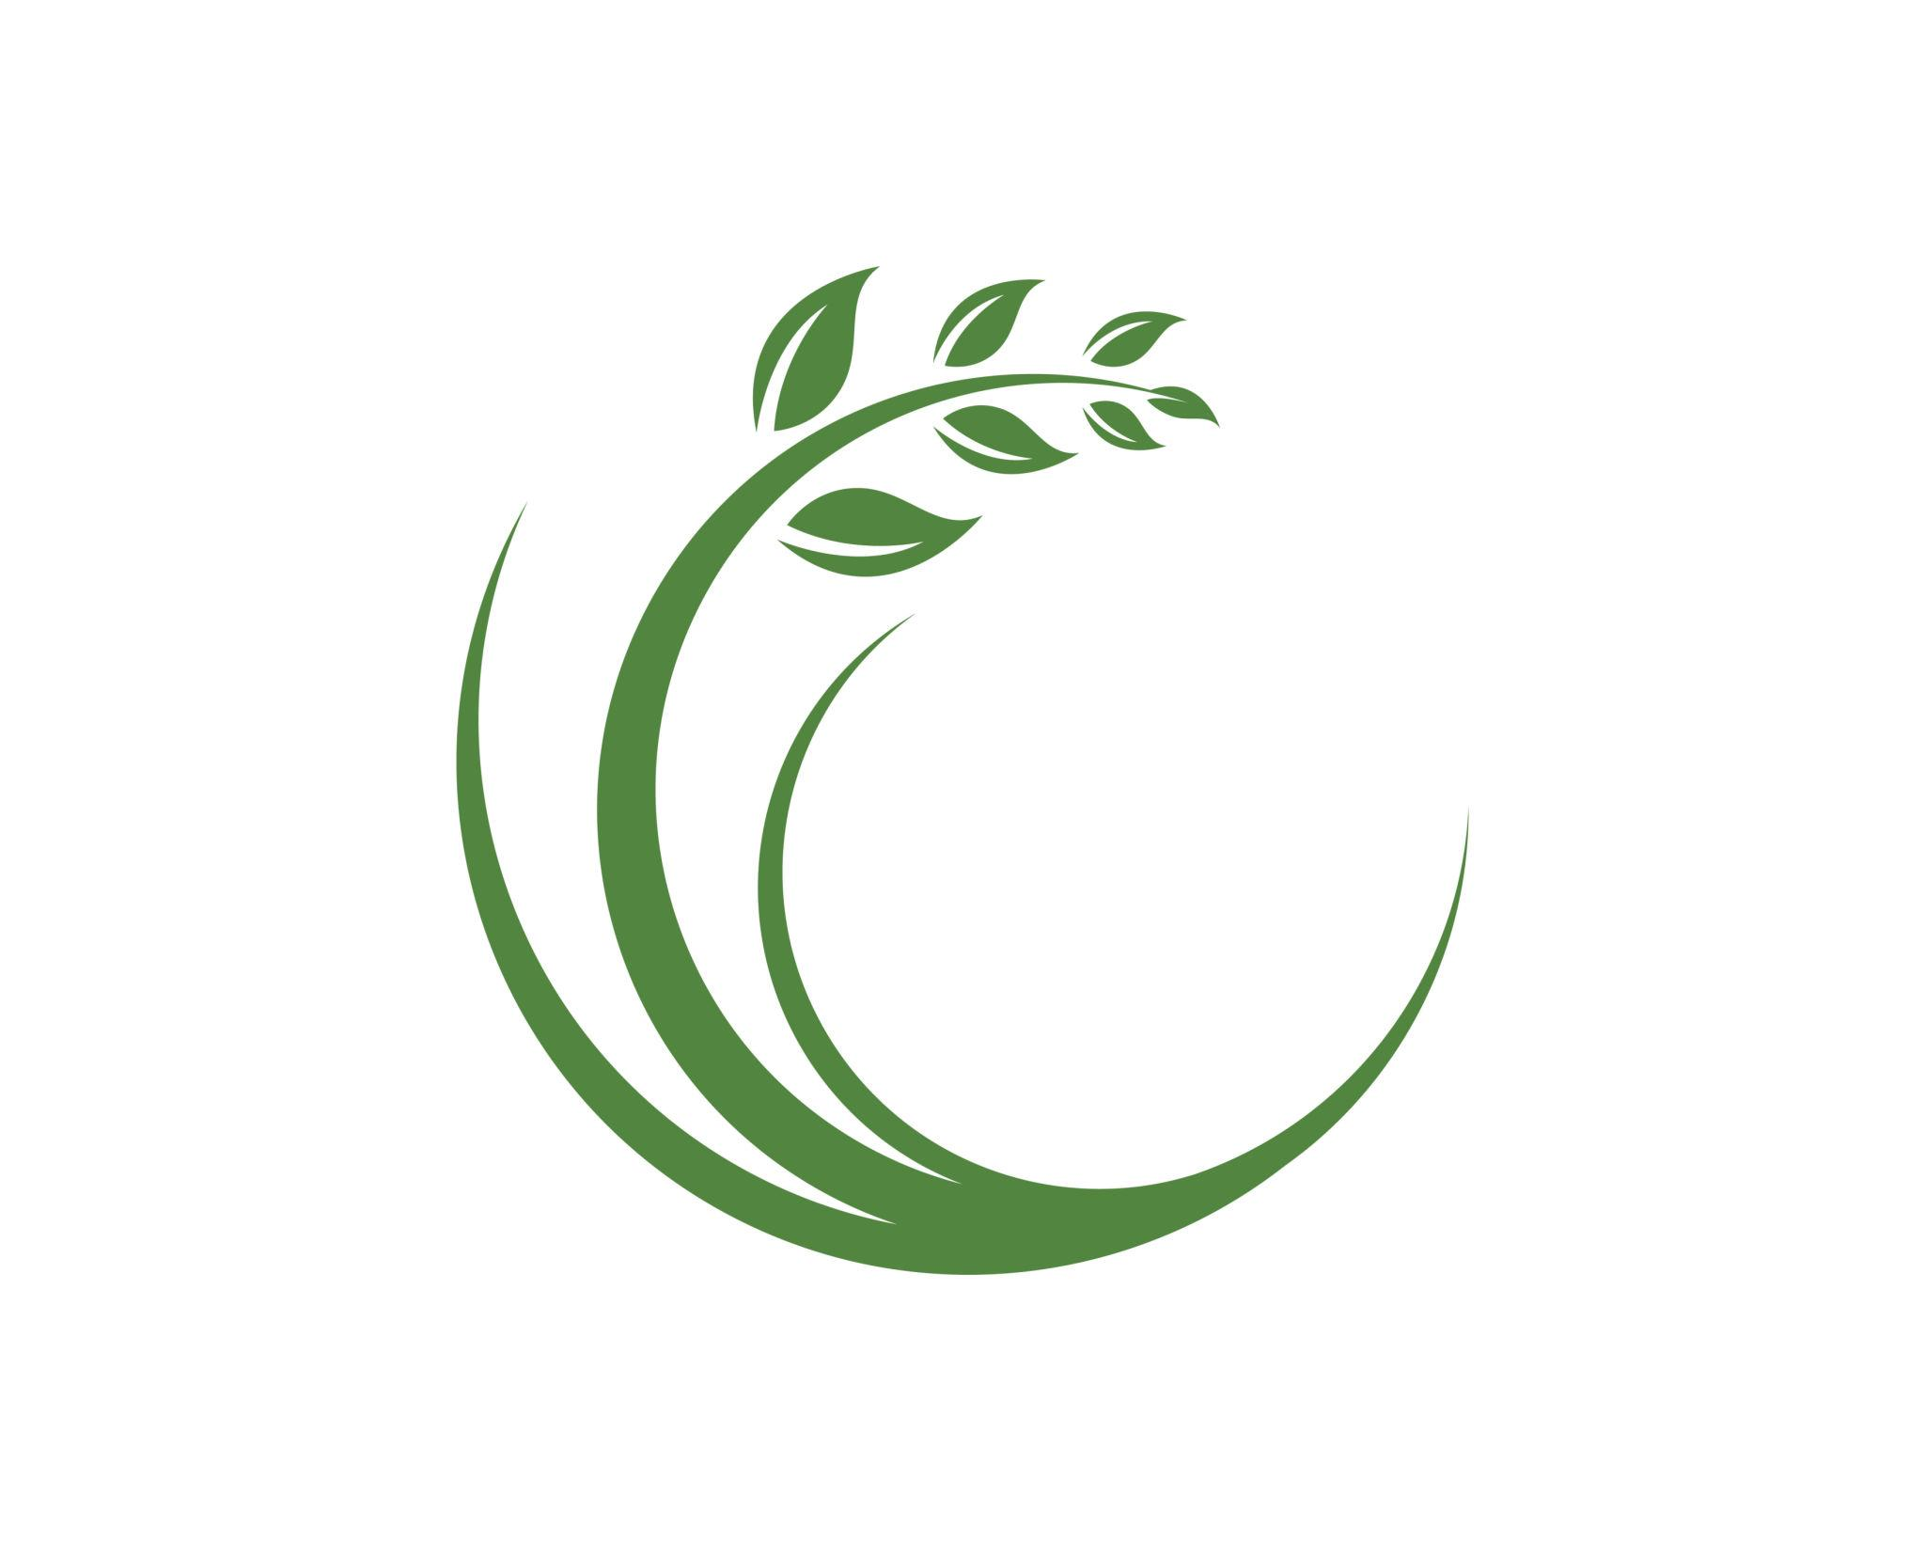

4. Single-Arc Circular–Organic Open Shape
# Source: AI Source: Provided by: [Data Path: Persons Table -> ID Column: 1, Name_En Column: Motasem Essam] -> From: [ChatGPT] on [7/25/2026]
An open shape containing one circular arc and one or more organic curves.
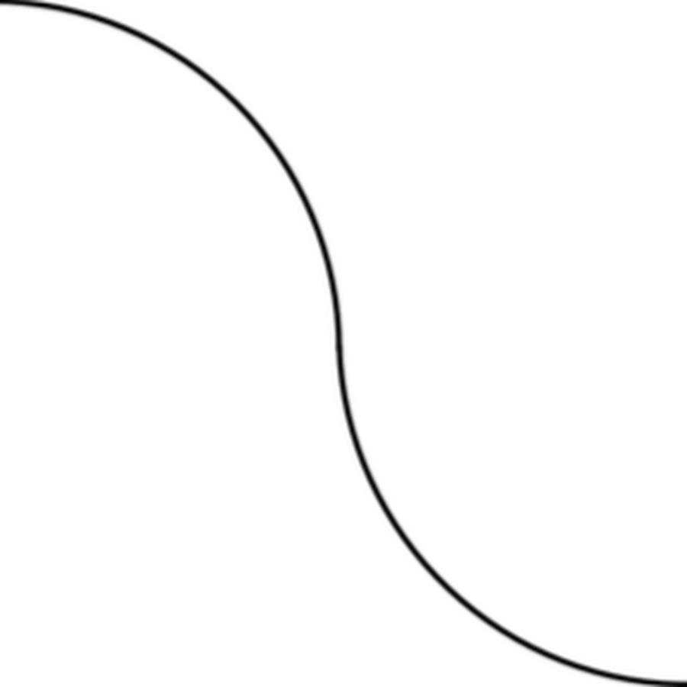
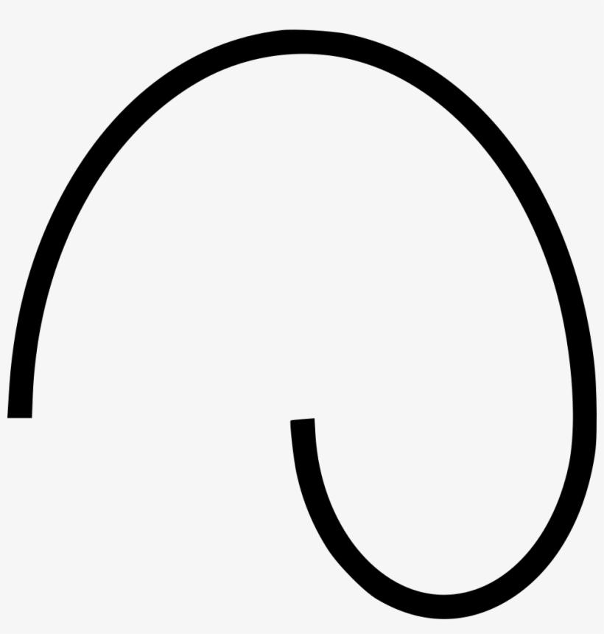

5. Multi-Arc Circular–Organic Open Shape
# Source: AI Source: Provided by: [Data Path: Persons Table -> ID Column: 1, Name_En Column: Motasem Essam] -> From: [ChatGPT] on [7/25/2026]
An open path containing several circular arcs connected by organic curved portions.
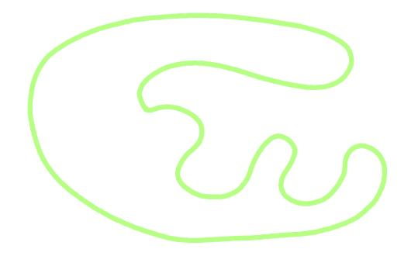
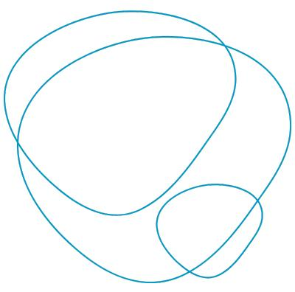
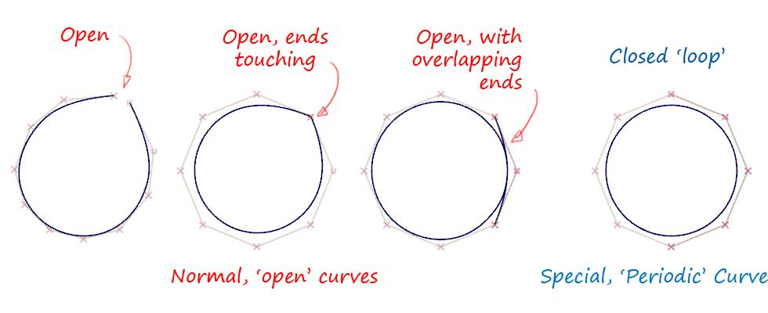

6. Smooth Circular–Organic Open Shape
# Source: AI Source: Provided by: [Data Path: Persons Table -> ID Column: 1, Name_En Column: Motasem Essam] -> From: [ChatGPT] on [7/25/2026]
Circular arcs transition smoothly into organic curves.

7. Wavy Circular–Organic Open Shape
# Source: AI Source: Provided by: [Data Path: Persons Table -> ID Column: 1, Name_En Column: Motasem Essam] -> From: [ChatGPT] on [7/25/2026]
Circular arcs are combined with organic curves that contain irregular waves or undulations.
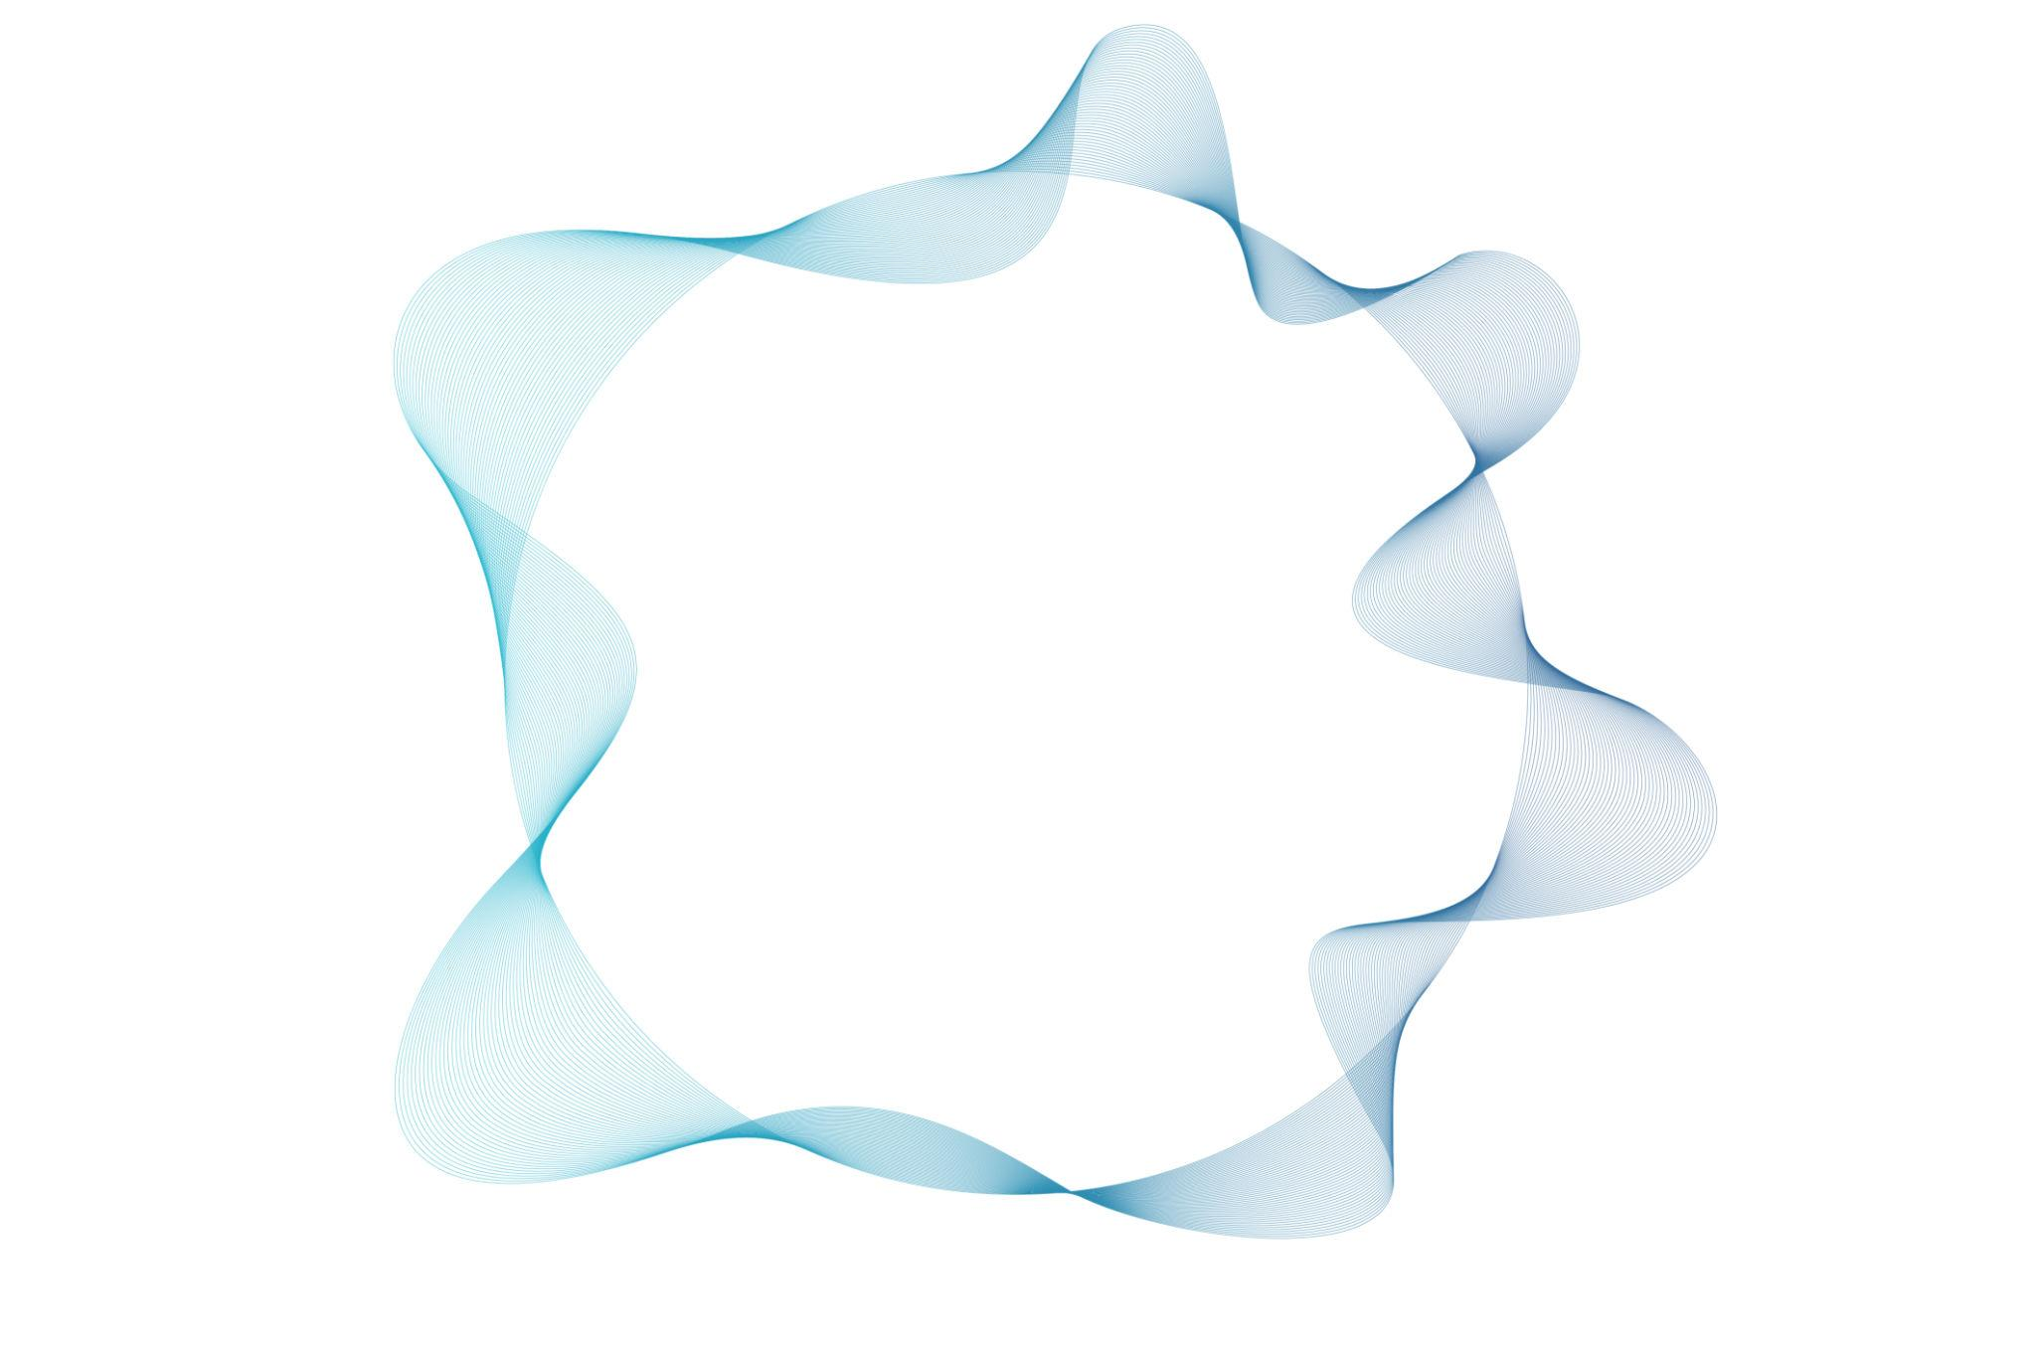
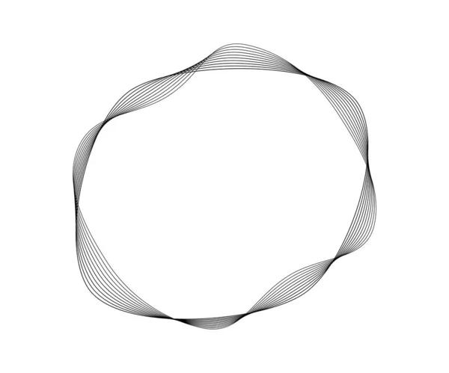
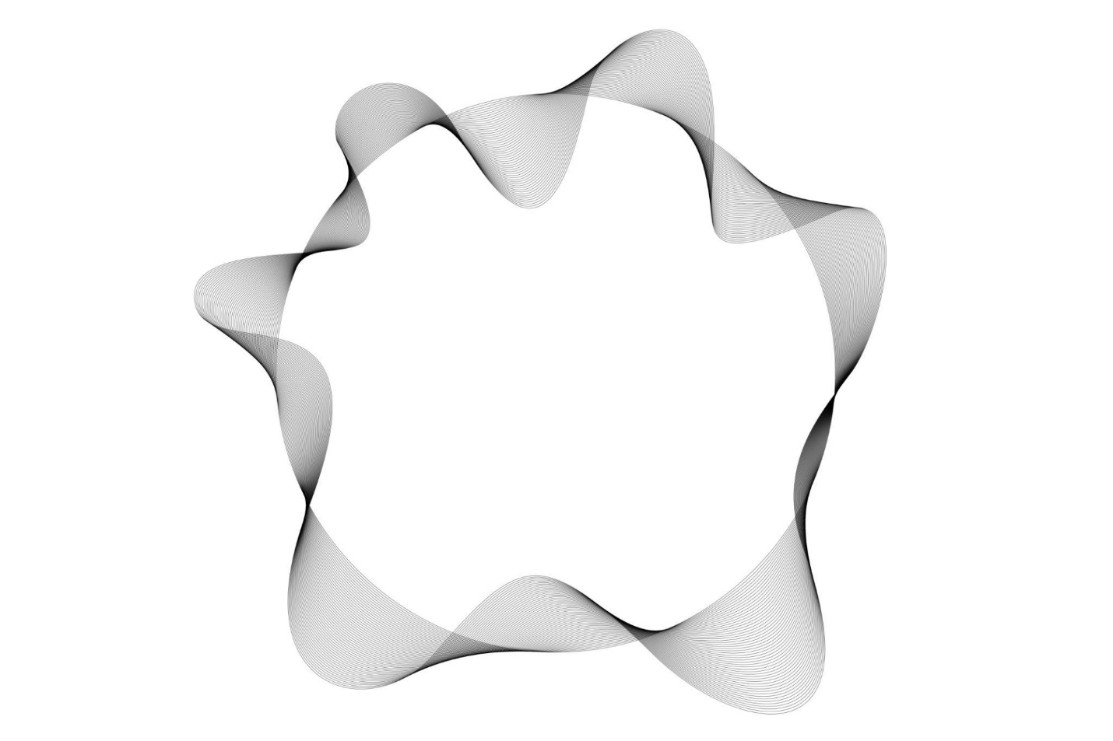

8. Spiral-Like Circular–Organic Open Shape
# Source: AI Source: Provided by: [Data Path: Persons Table -> ID Column: 1, Name_En Column: Motasem Essam] -> From: [ChatGPT] on [7/25/2026]
A circular portion is combined with an organic curve that winds around a central region.
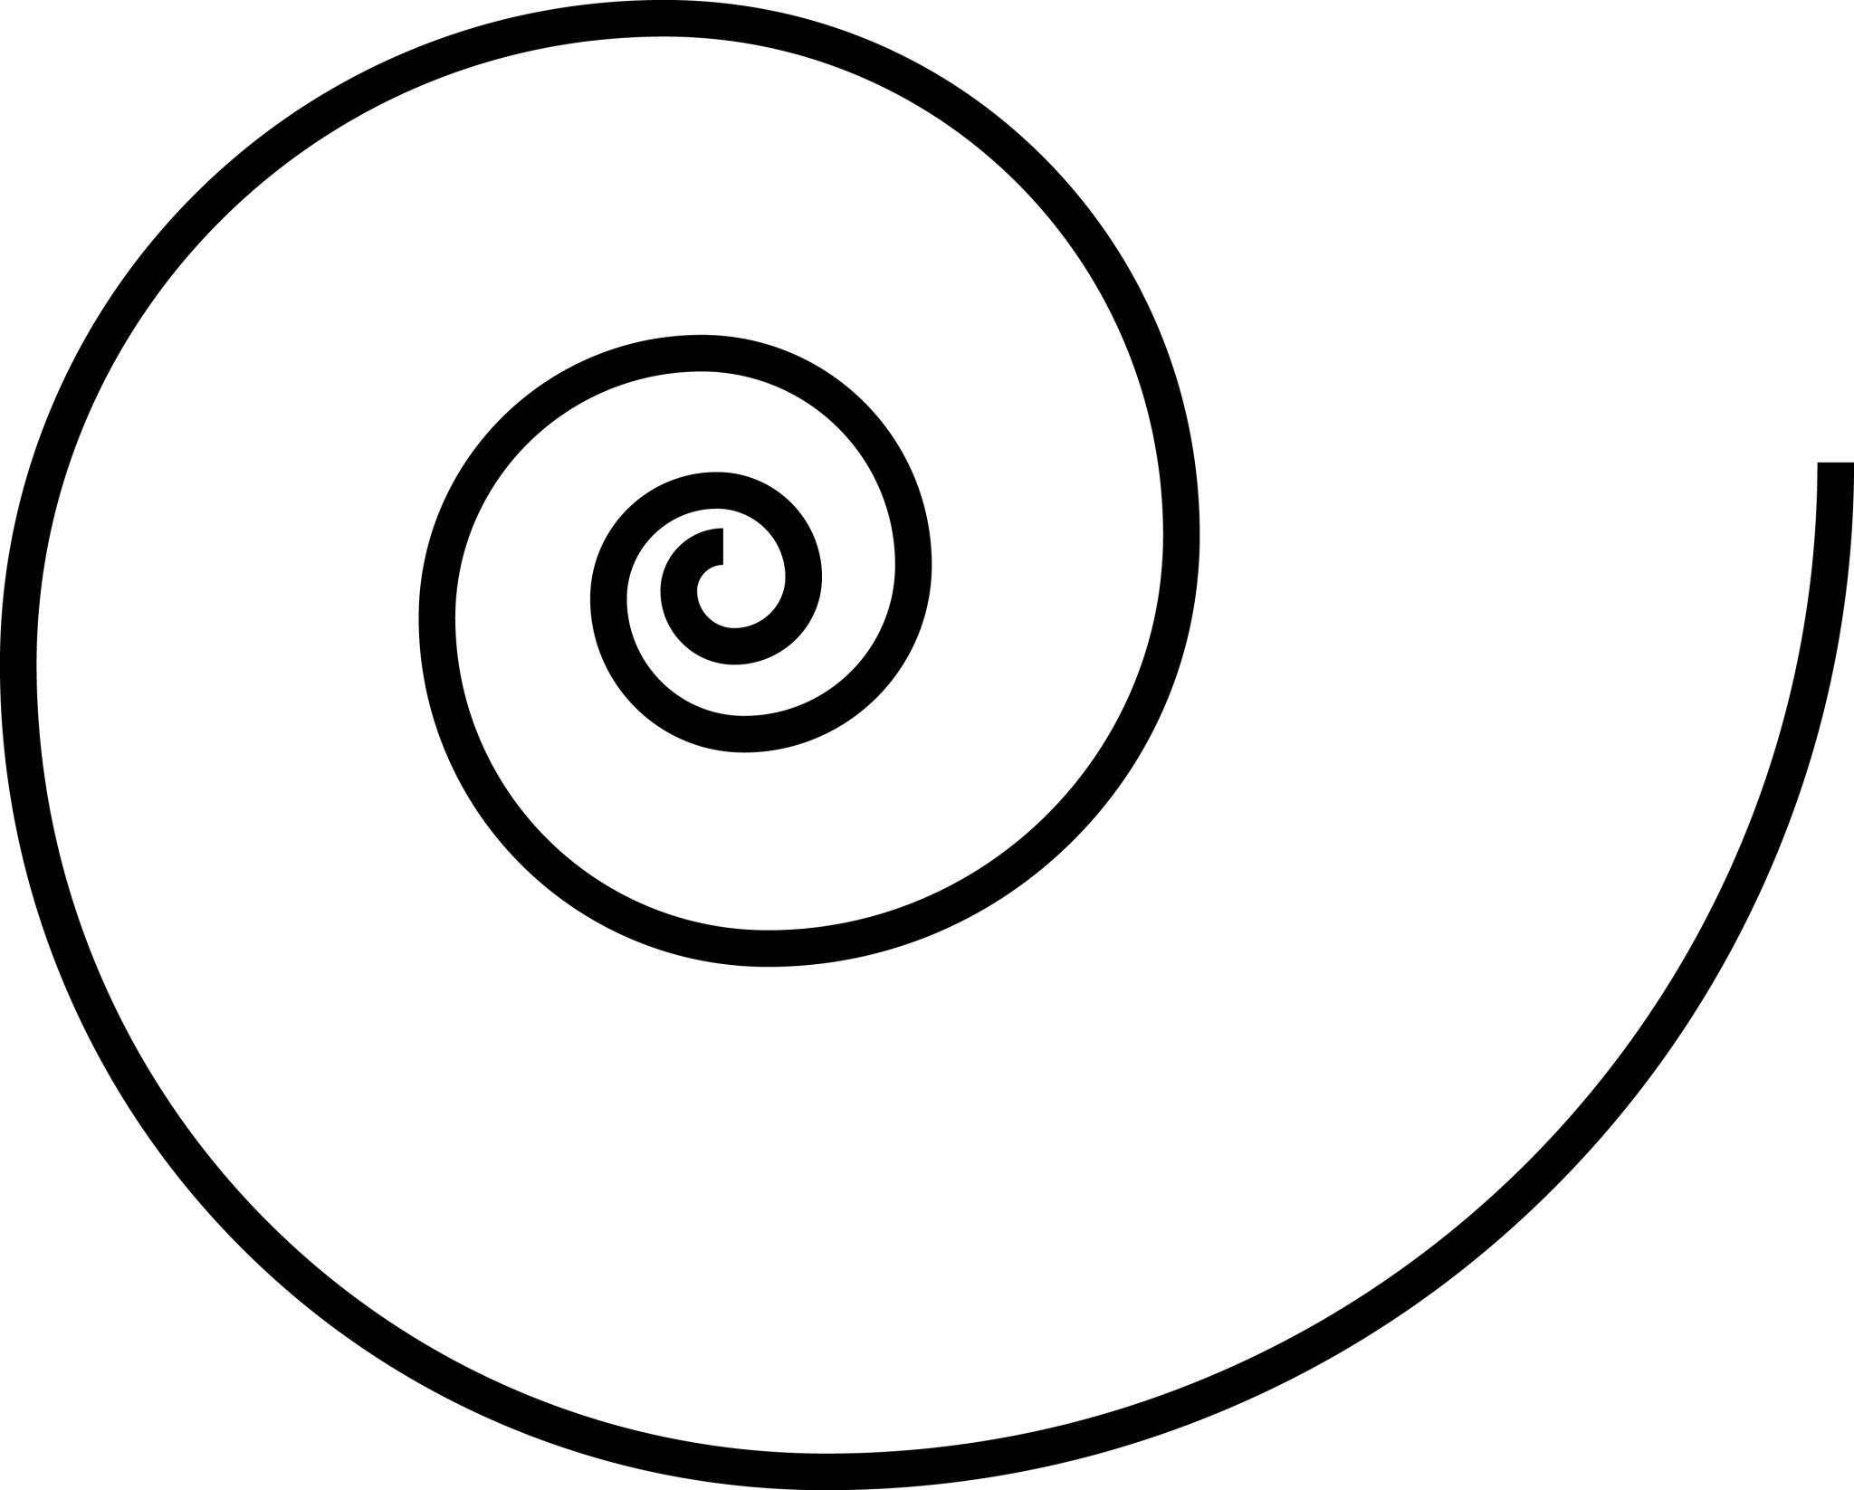
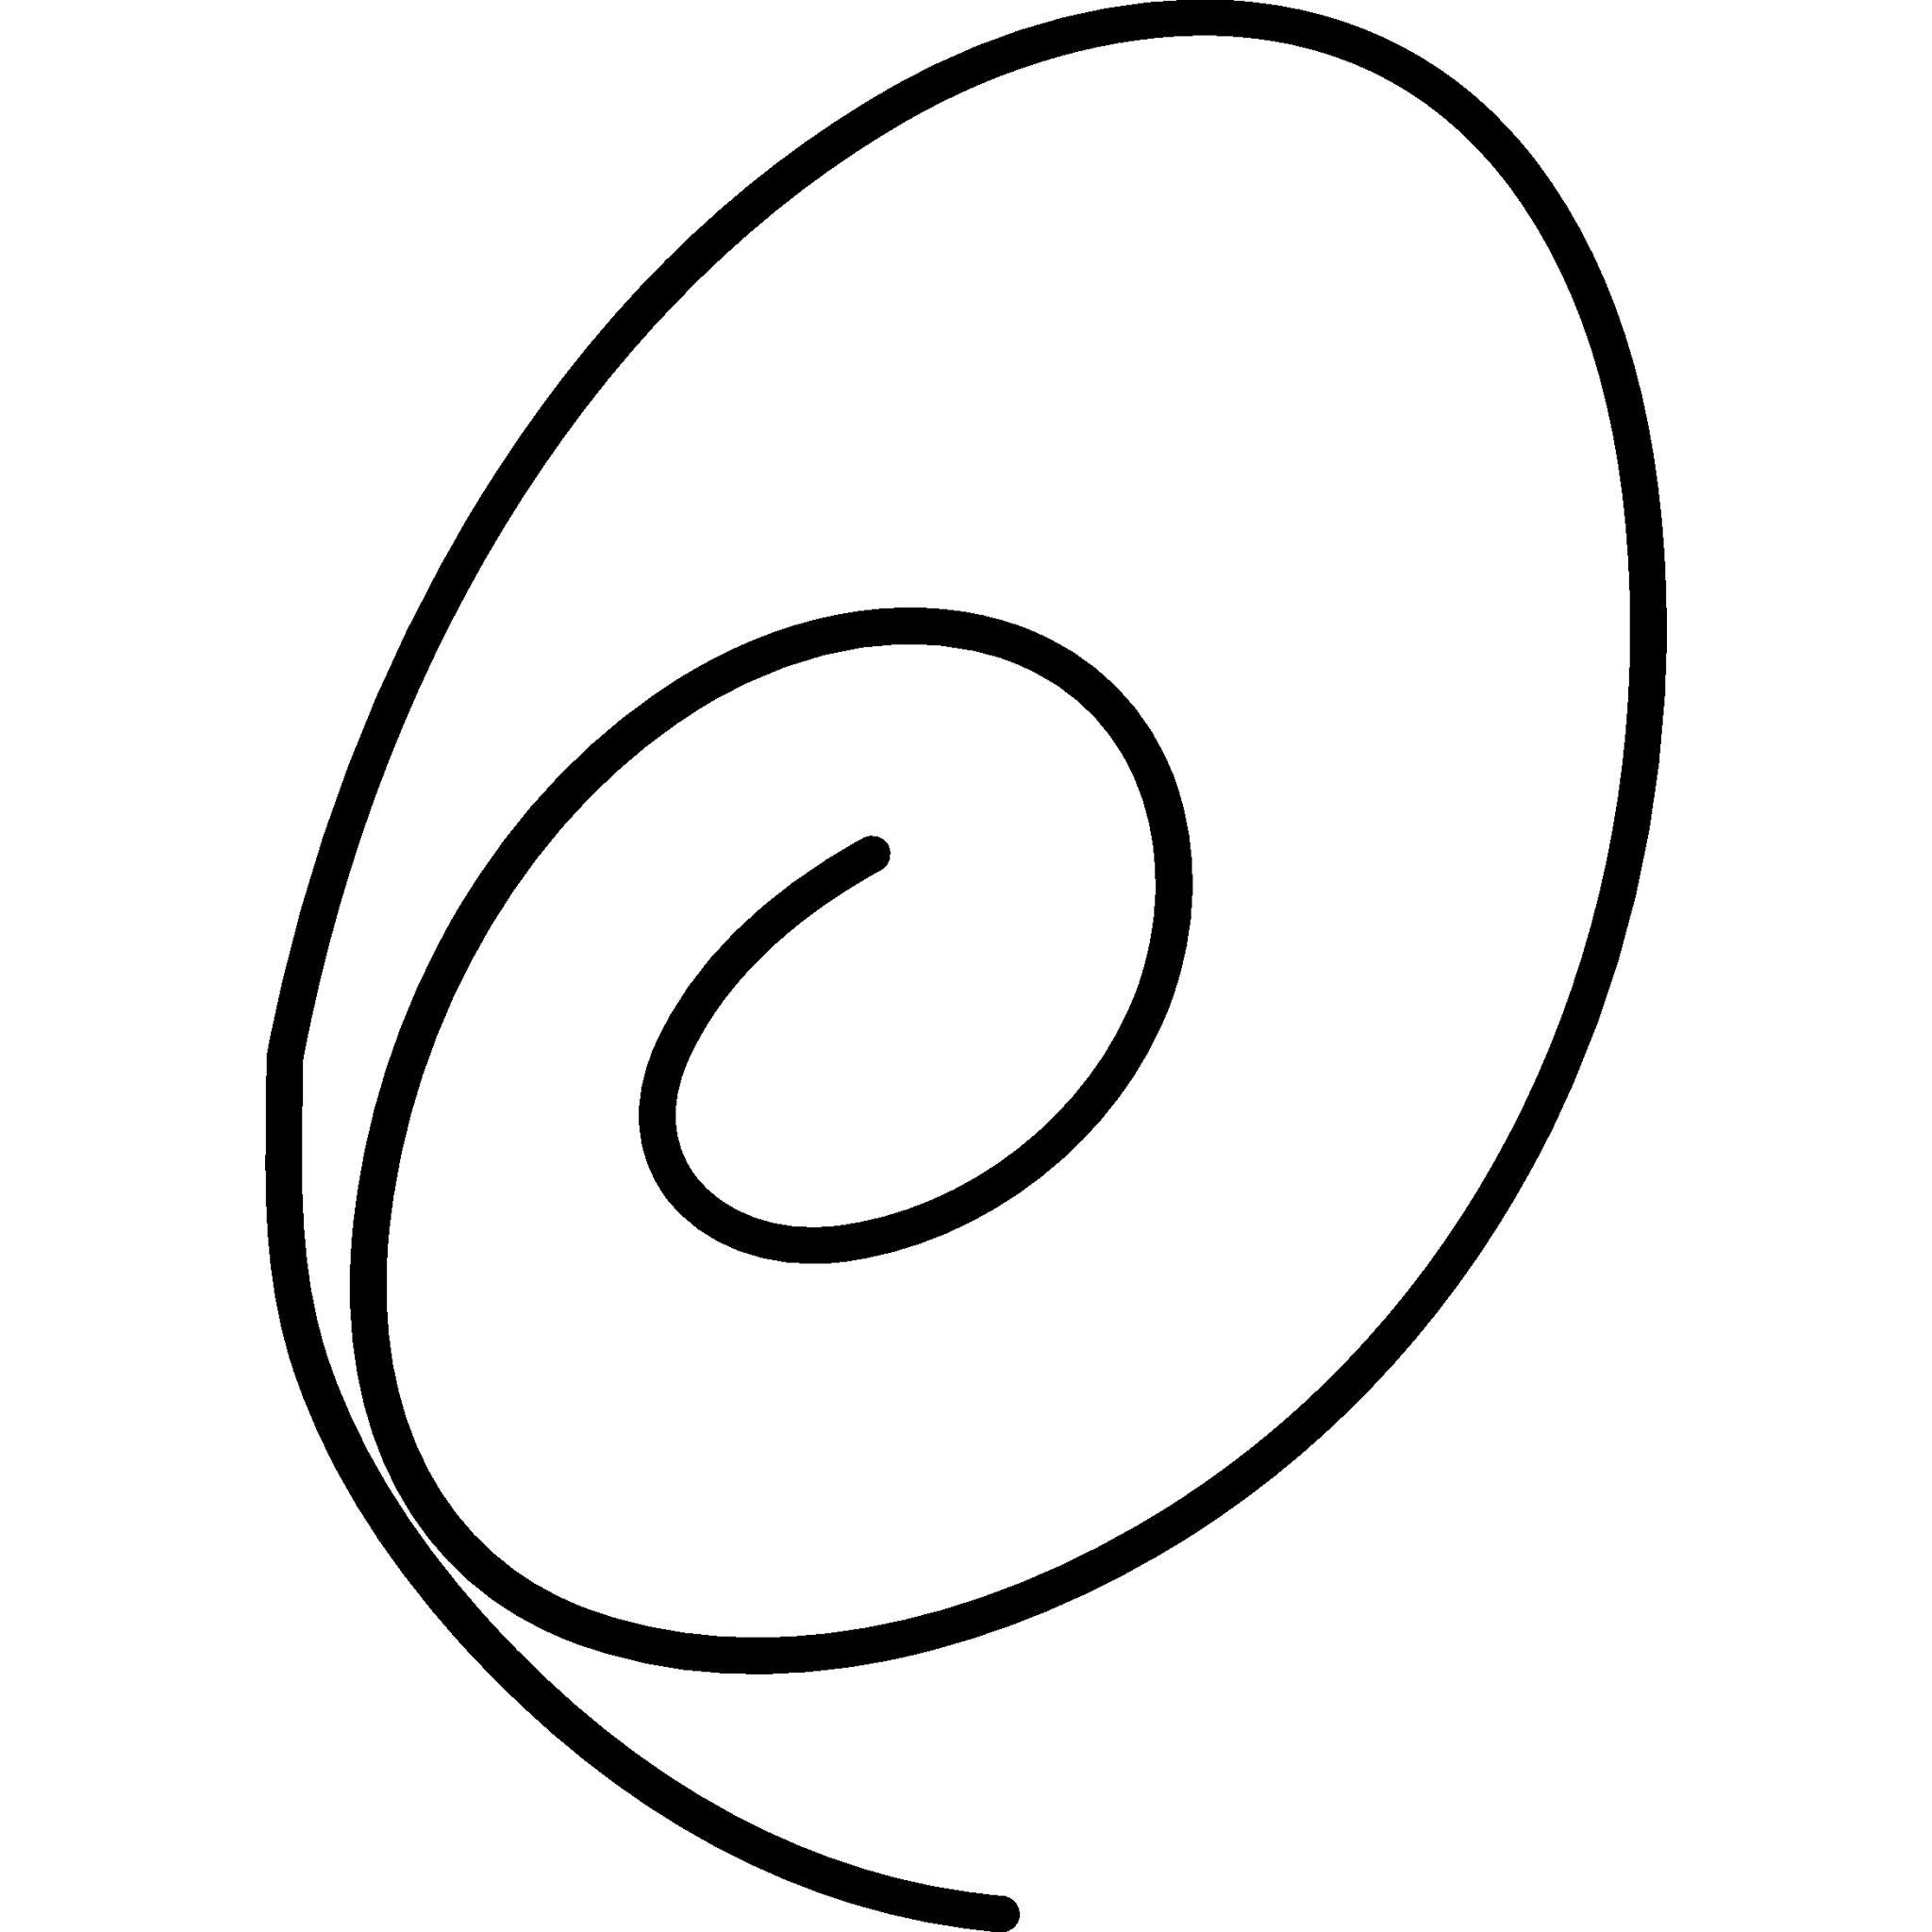
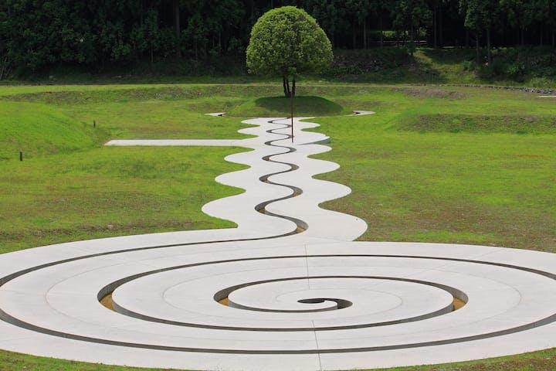
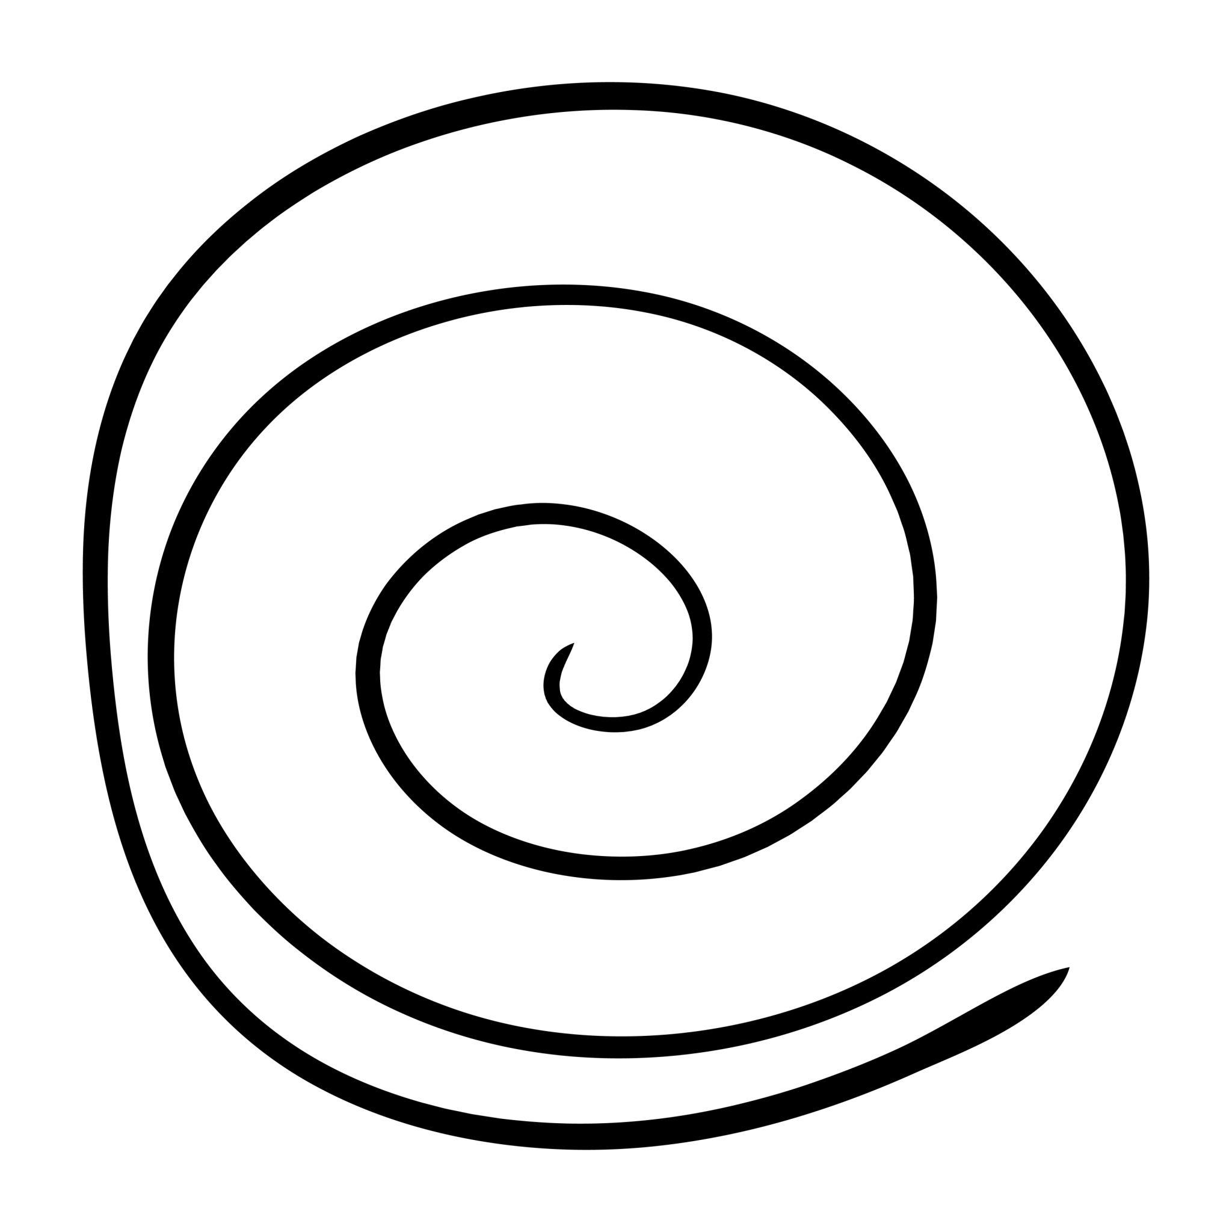
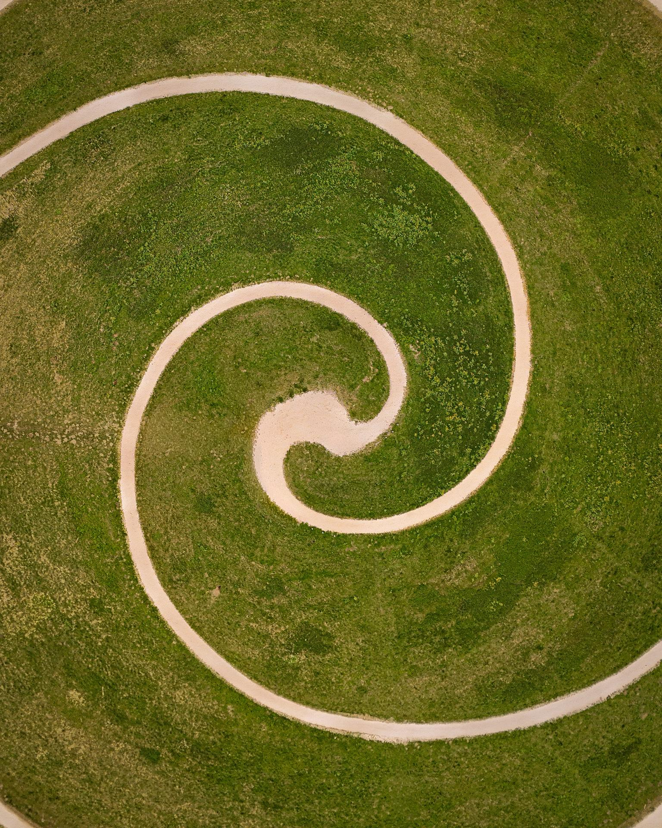
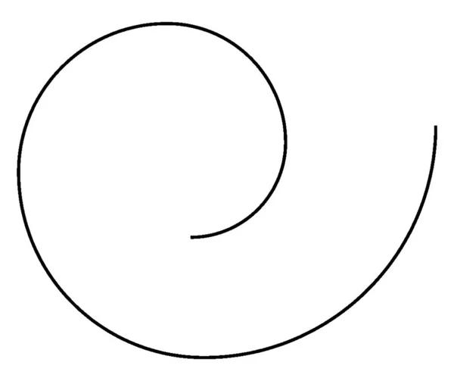

9. Symmetric Circular–Organic Open Shape
# Source: AI Source: Provided by: [Data Path: Persons Table -> ID Column: 1, Name_En Column: Motasem Essam] -> From: [ChatGPT] on [7/25/2026]
The circular and organic portions are arranged around a recognizable axis of symmetry.
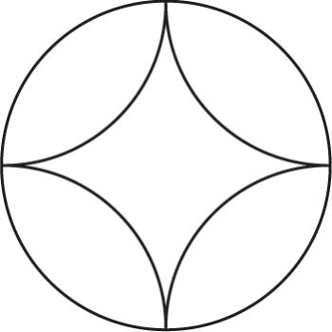
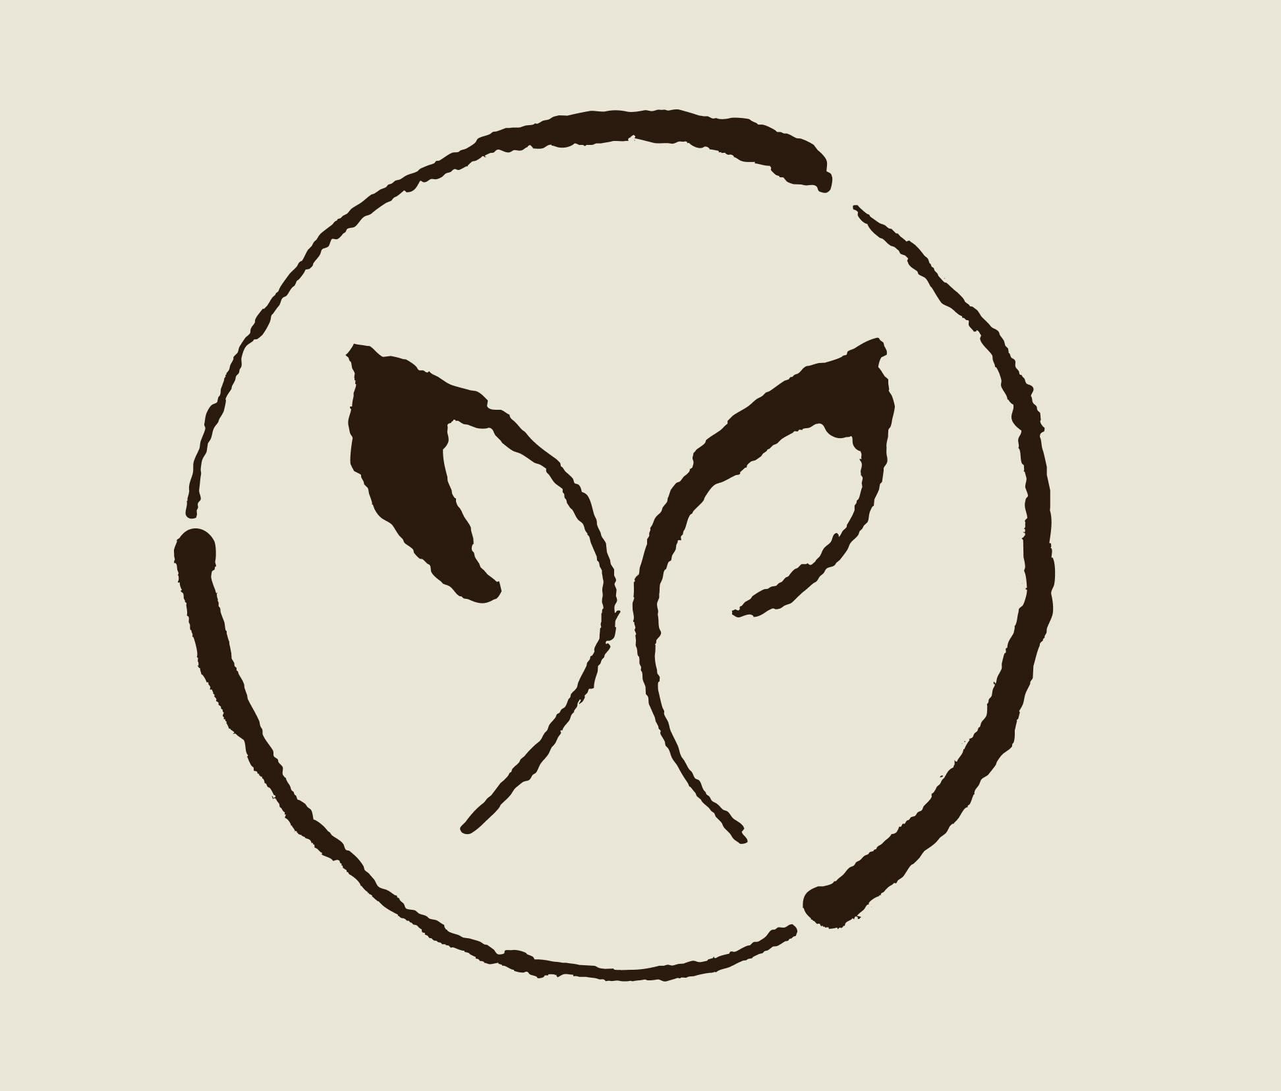
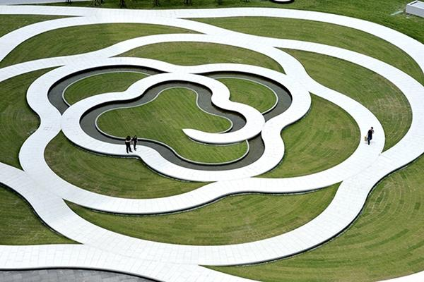

10. Asymmetric Circular–Organic Open Shape
# Source: AI Source: Provided by: [Data Path: Persons Table -> ID Column: 1, Name_En Column: Motasem Essam] -> From: [ChatGPT] on [7/25/2026]
The circular and organic portions have different sizes, positions, or curvature, producing an asymmetric form.

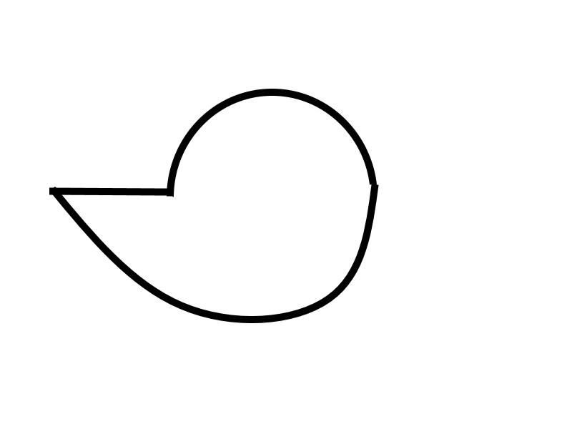

11. Tangential Circular–Organic Open Shape
# Source: AI Source: Provided by: [Data Path: Persons Table -> ID Column: 1, Name_En Column: Motasem Essam] -> From: [ChatGPT] on [7/25/2026]
A circular arc connects smoothly to an organic curve at a common tangent direction.
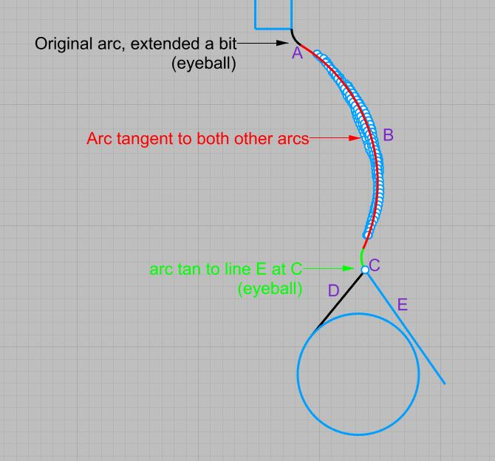
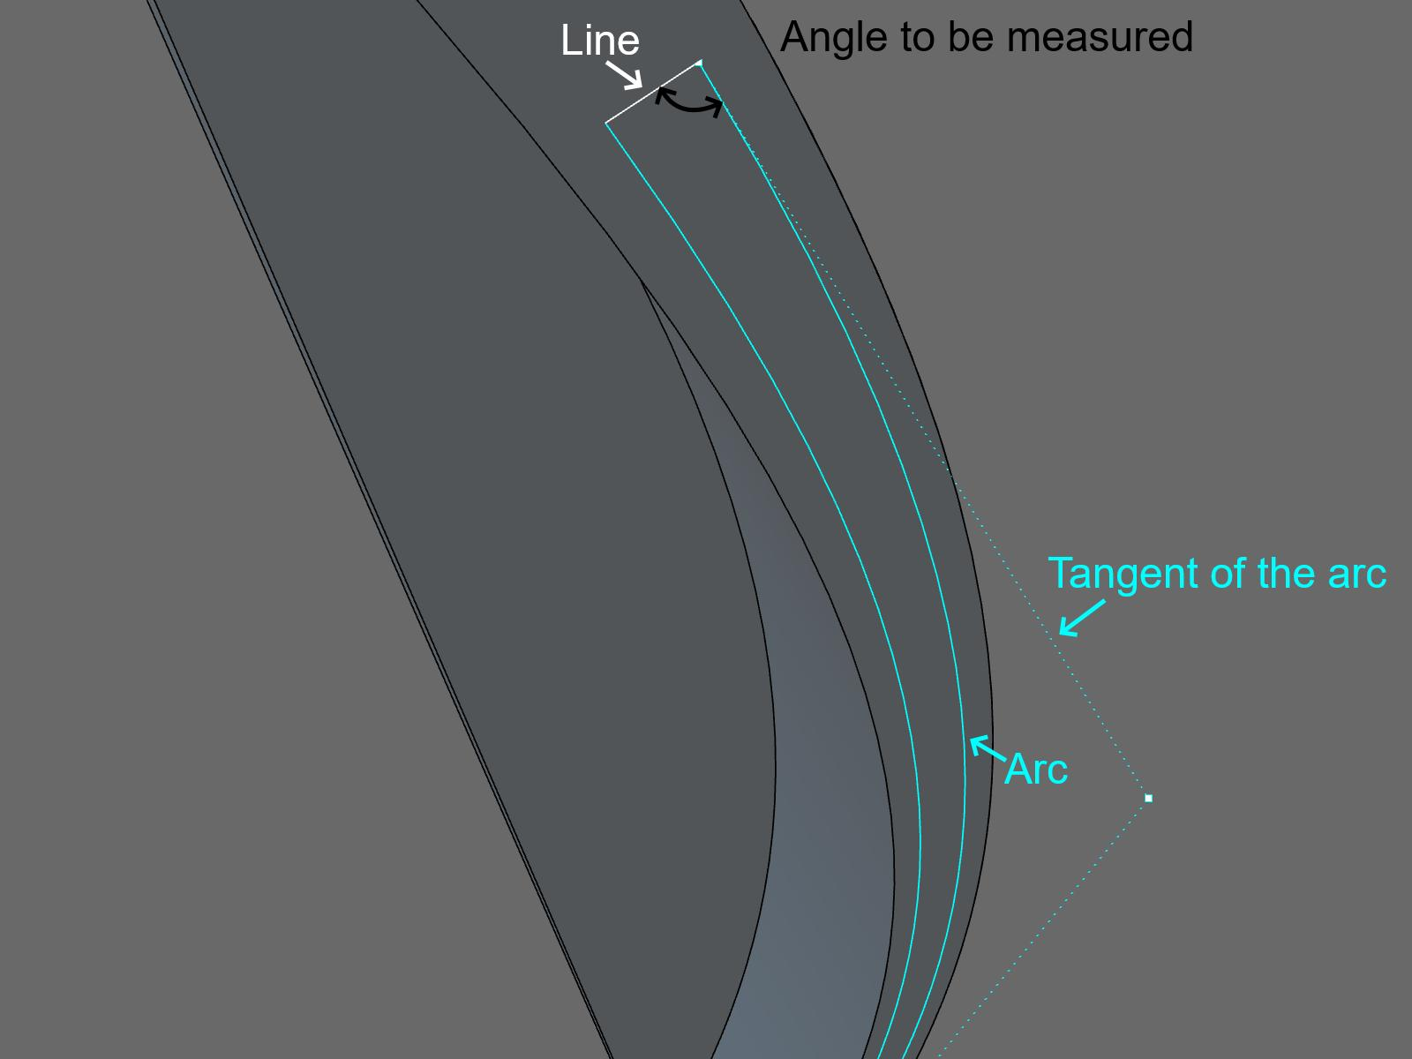
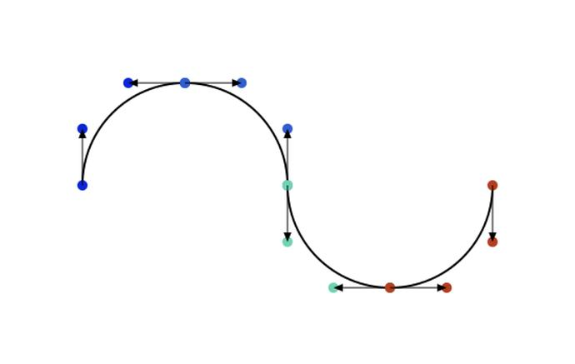
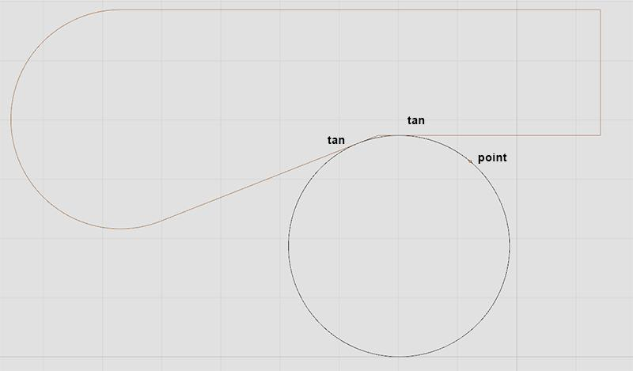
This produces a visually smooth transition between the two curve types.

12. Freeform Circular–Organic Open Shape
# Source: AI Source: Provided by: [Data Path: Persons Table -> ID Column: 1, Name_En Column: Motasem Essam] -> From: [ChatGPT] on [7/25/2026]
A freely designed open path combining circular arcs and organic curves without a fixed standard arrangement.
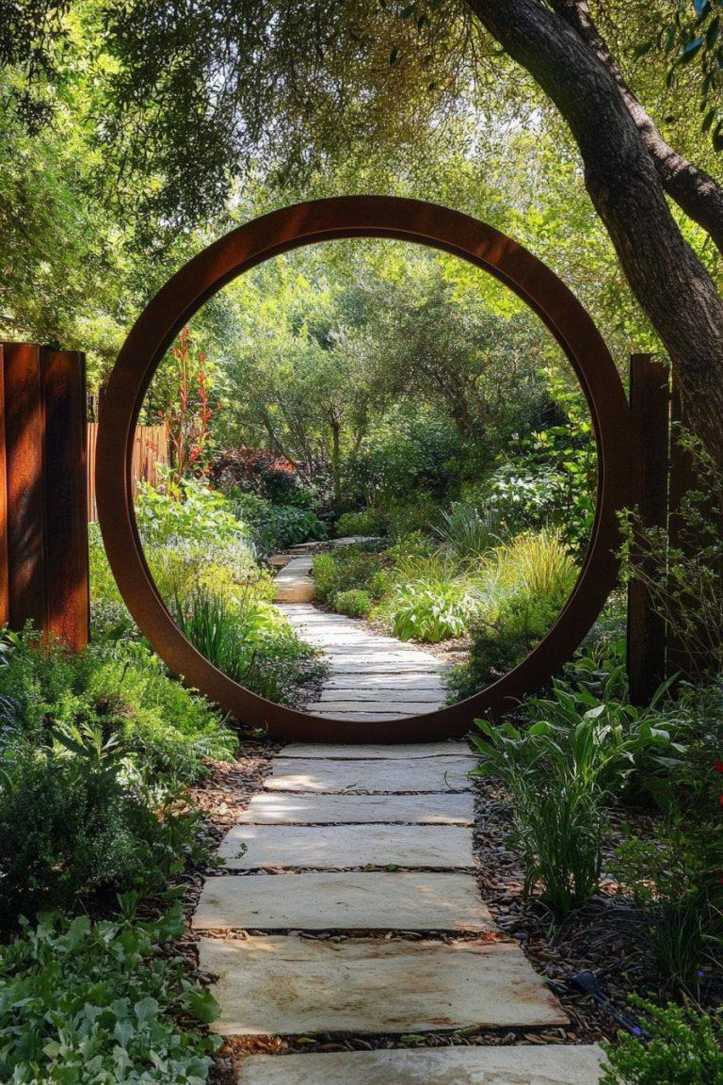
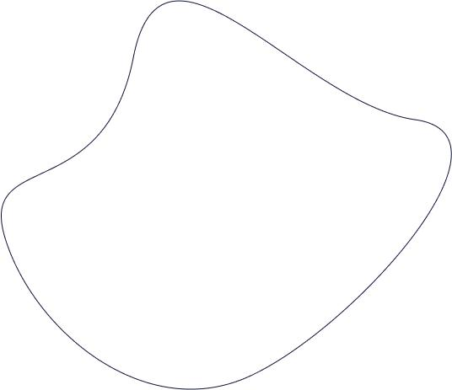

Circular–Organic vs. Circular–Freeform Open Shapes
# Source: AI Source: Provided by: [Data Path: Persons Table -> ID Column: 1, Name_En Column: Motasem Essam] -> From: [ChatGPT] on [7/25/2026]
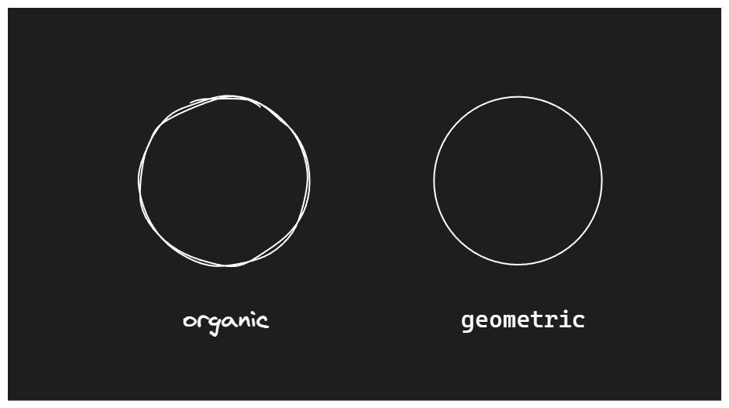
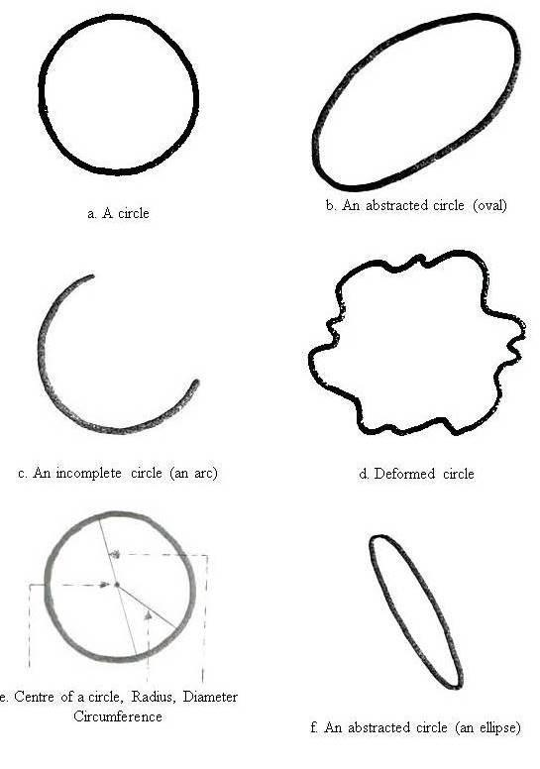
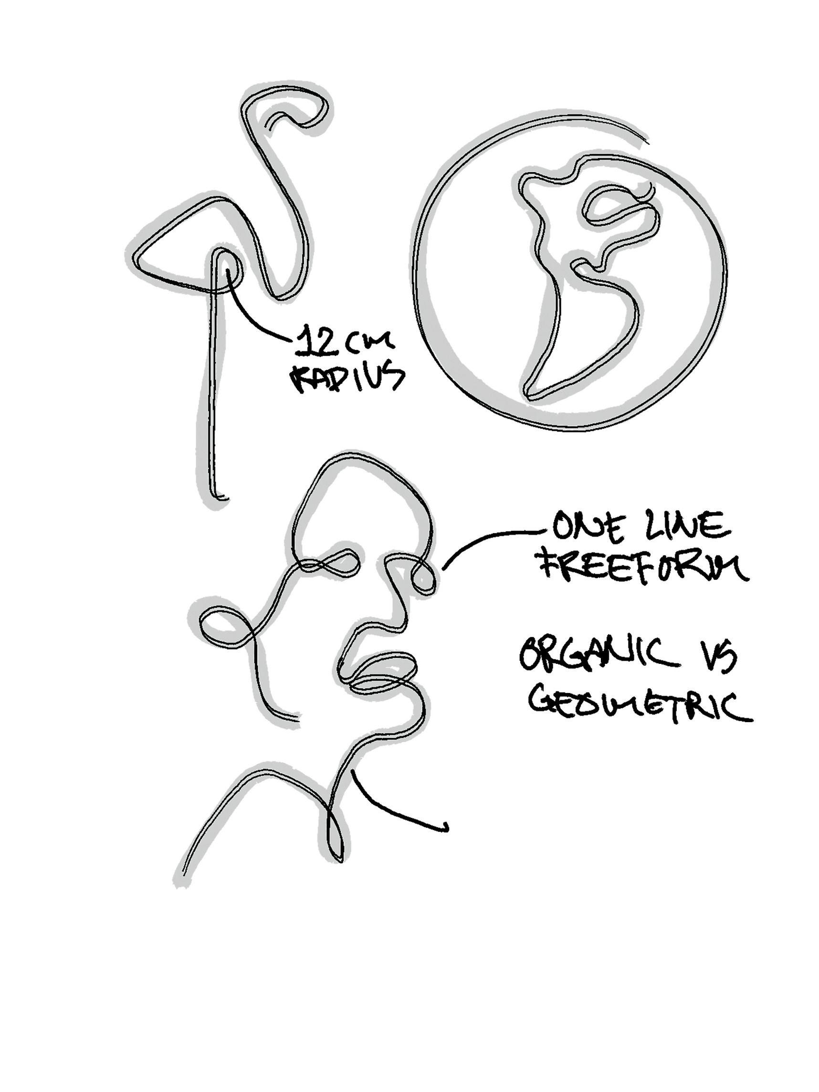
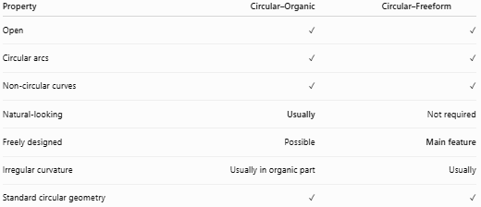
Property | Circular–Organic | Circular–Freeform
Open | ✓ | ✓
Circular arcs | ✓ | ✓
Non-circular curves | ✓ | ✓
Natural-looking | Usually | Not required
Freely designed | Possible | Main feature
Irregular curvature | Usually in organic part | Usually
Standard circular geometry | ✓ | ✓
Main distinction
$$\boxed{\text{Circular–Organic}=\text{Circular Arc(s) + Natural-Looking Curves}}$$
while:
$$\boxed{\text{Circular–Freeform}=\text{Circular Arc(s) + Freely Designed Curves}}$$

Circular–Organic vs. Polygon–Organic Open Shapes
# Source: AI Source: Provided by: [Data Path: Persons Table -> ID Column: 1, Name_En Column: Motasem Essam] -> From: [ChatGPT] on [7/25/2026]
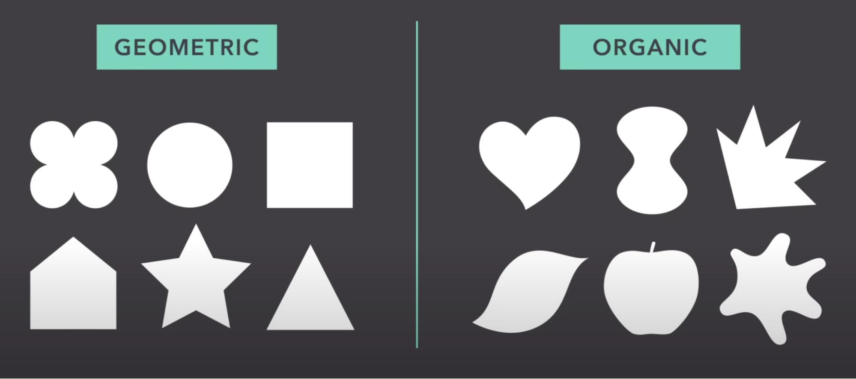
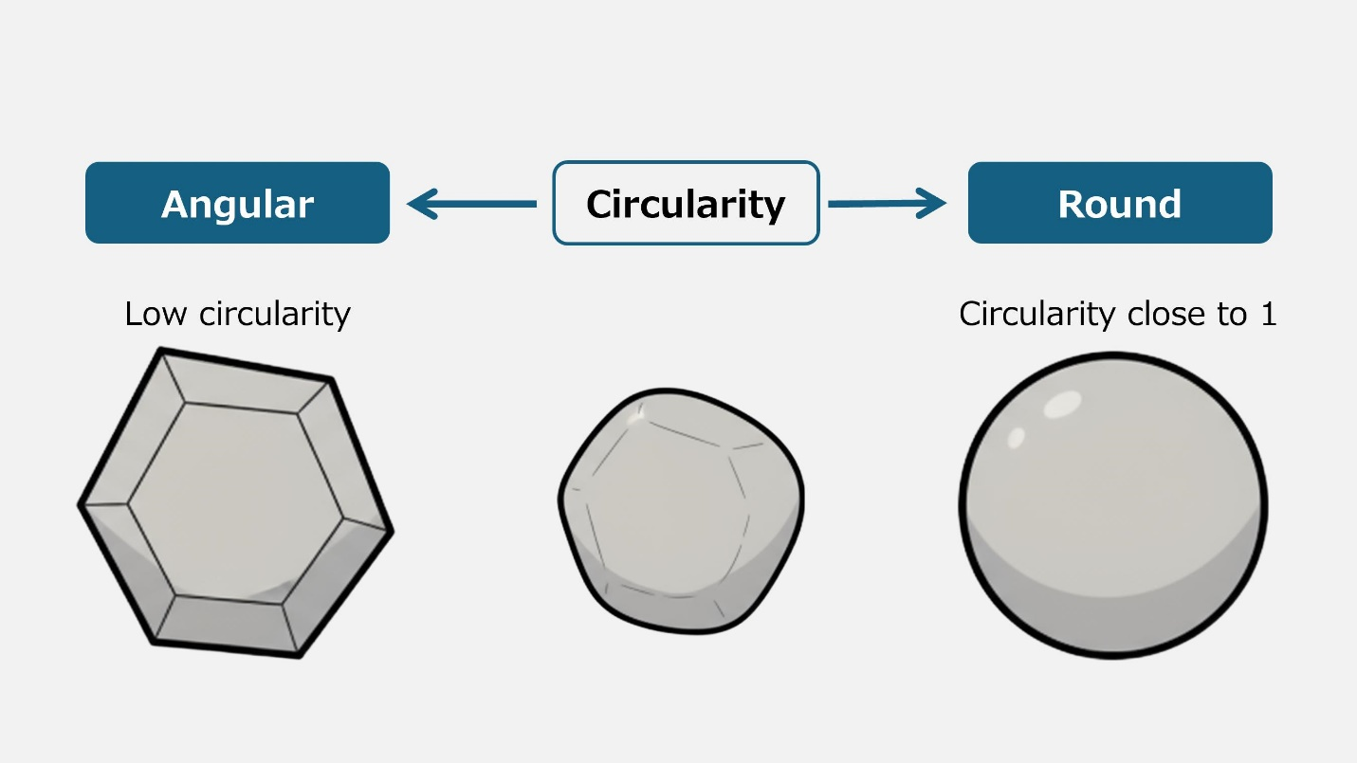
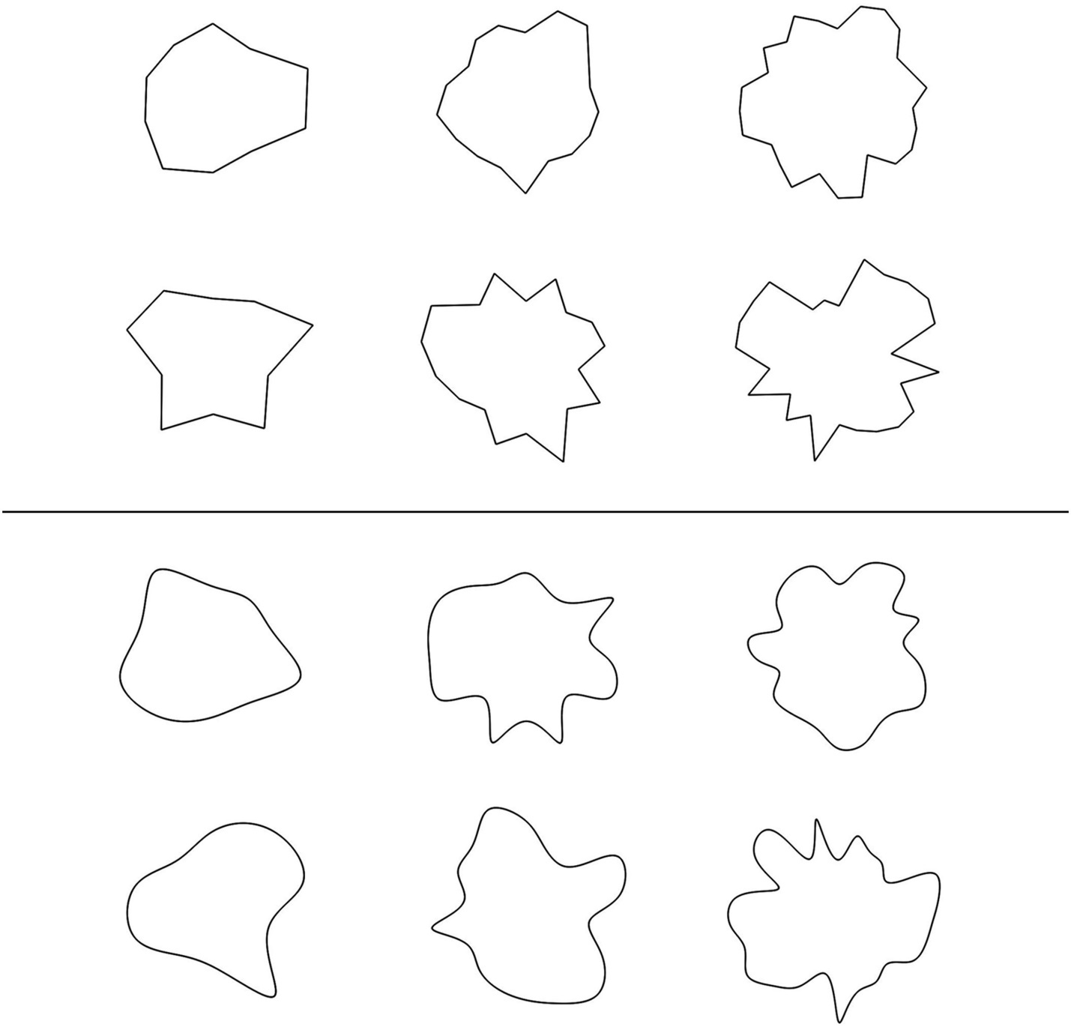
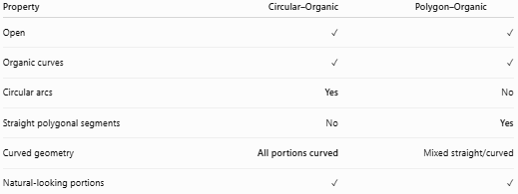
Property | Circular–Organic | Polygon–Organic
Open | ✓ | ✓
Organic curves | ✓ | ✓
Circular arcs | Yes | No
Straight polygonal segments | No | Yes
Curved geometry | All portions curved | Mixed straight/curved
Natural-looking portions | ✓ | ✓

Circular–Organic vs. Pure Organic Open Curves
# Source: AI Source: Provided by: [Data Path: Persons Table -> ID Column: 1, Name_En Column: Motasem Essam] -> From: [ChatGPT] on [7/25/2026]
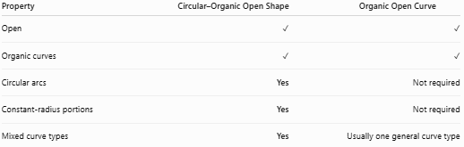
Property | Circular–Organic Open Shape | Organic Open Curve
Open | ✓ | ✓
Organic curves | ✓ | ✓
Circular arcs | Yes | Not required
Constant-radius portions | Yes | Not required
Mixed curve types | Yes | Usually one general curve type
The circular component is what makes the first category a mixed shape.

Key Points
# Source: AI Source: Provided by: [Data Path: Persons Table -> ID Column: 1, Name_En Column: Motasem Essam] -> From: [ChatGPT] on [7/25/2026]
A Circular–Organic Open Shape is:
$$\boxed{\text{Open}+\text{Circular}+\text{Organic}}$$
It:
- Contains one or more circular arcs.
- Contains one or more organic curves.
- Remains open.
- Does not enclose an area by itself.
- Combines regular circular curvature with irregular natural-looking curvature.
- May be smooth, wavy, spiral-like, symmetric, asymmetric, or freeform.
- Can contain one or multiple circular arcs.

Conclusion
# Source: AI Source: Provided by: [Data Path: Persons Table -> ID Column: 1, Name_En Column: Motasem Essam] -> From: [ChatGPT] on [7/25/2026]
Circular–Organic Open Shapes combine the regular geometry of circular arcs with the irregular, flowing character of organic curves while maintaining an open path. The key distinction is that the circular portions have a circular geometric structure, whereas the organic portions are characterized primarily by their natural-looking and irregular curvature.

